# AI-Powered Module Creation User Guide

Contents

AI-Powered Module Creation User Guide 1

Overview 3

Install AI-Powered Module Creation Extension 3

Create a new module or open an existing module 5

Creating a new Module from Scratch 5

Open an existing Module 10

Module Design 12

Unit Design 15

Conceptual Unit Design 15

Exercise Unit Design 23

Supplemental Unit Design 30

Content Refine 32

Content Refine Assistant 32

Add content 33

Refine select content 38

Clean Unused Images 40

Boost Acrolinx 41

Create MS Learn Image Tag 42

Update to bullet list 44

Update to Numbering list 45

Update Pub2Learn/Direct Publishing Module 46

Update Pub2Learn Module 46

Update Direct Publishing Module 50

Best Practice 53

Troubleshooting 54

## Overview

AI-Powered Module Creation is an AI-driven authoring tool designed to accelerate the creation of Learn Modules. The tool is integrated into VS Code and presented as a VS Code Extension. It enhances user productivity during both the authoring and content refinement stages.

**Authoring Stage**

The tool leverages AI to help users quickly build the module file structure, search for data sources, and generate the structure for Unit articles. Based on user adjustments to the data sources and article structures, it ultimately generates **Conceptual Units** and **Exercise Units**. Users can rely on AI to search for data sources or customize them by providing their own URLs and documents, ensuring precise data source customization. Additionally, the tool can use existing Unit content to generate **Supplemental Units**, such as **Introductions**, **Knowledge Checks**, and **Summaries**.

**Content Refinement Stage**

After generating Unit content during the **Authoring Stage**, the user transitions to the **Unit Content Refinement Stage**. During the refinement stage, users can utilize the tool's AI capabilities to polish and enhance existing content by users’ own prompts. It can also generate content snippets from user-provided URLs and documents, enabling deeper content expansion. Furthermore, the tool includes common editing features, such as Boost Acrolinx scores and converting image tags into Learn Image Tag, reducing repetitive manual tasks and improving editing efficiency.

## Install AI-Powered Module Creation Extension

In this section, you will learn how to install the **AI-Powered Module Creation** extension in VS Code.

1. In VS Code, click on **Extensions** in the sidebar to open the **Extension Marketplace**. Type **AI-Powered Module Creation** in the search bar.

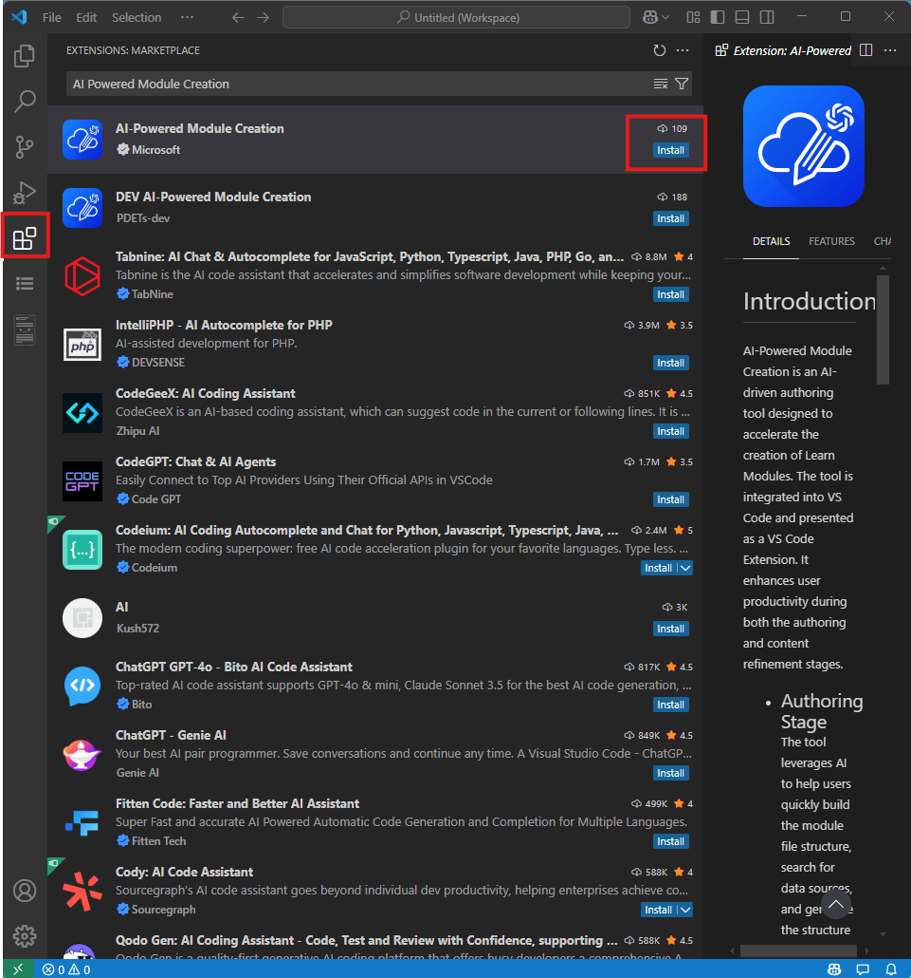

1. Click the **Install** button in the bottom-right corner of the extension to install it.
2. Once the installation is complete, you will see the **AI-Powered Module Creation** extension's launch button in the sidebar.

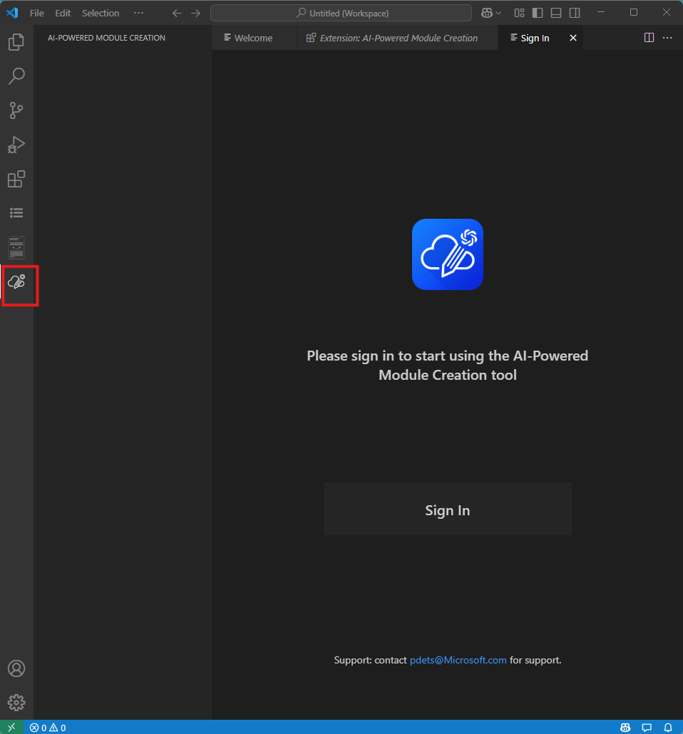

## Create a new module or open an existing module

In this section, you will learn how to use the **AI-Powered Module Creation** extension to quickly scaffold a module or open a module previously created with **AI-Powered Module Creation**.

### Creating a new Module from Scratch

This feature is useful when the user needs to create a module from scratch.

1. Click the **AI-Powered Module Creation** icon in the sidebar to sign.If you don’t have access, please reach pdets@microsoft.com.  
   
2. launch the main interface. Select **Create a new module from Scratch** .

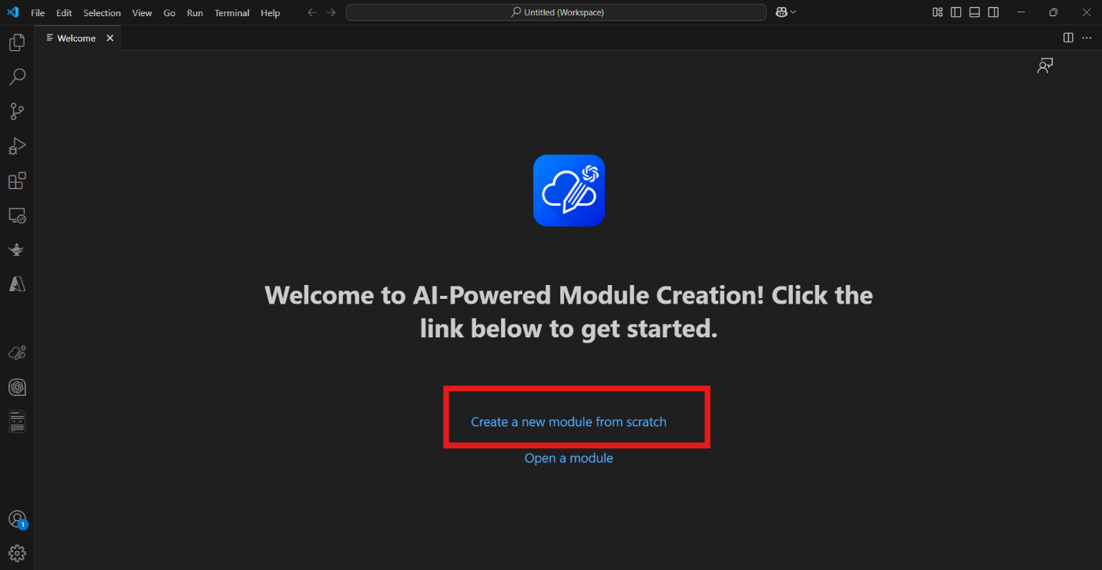

1. Select parent folder of module in **Select the parent folder for the module** dialogue box. Click **Open** button.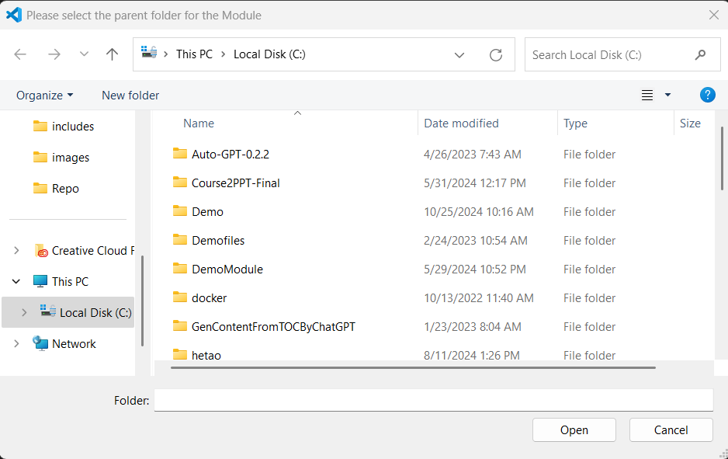
2. Initialize the module's basic information by entering the Module Title, Product, and Target Audience. Then, input the Unit Title and select a Unit Template.  
   **Note:** When you select product, you can select multiple products and also search in the product list.

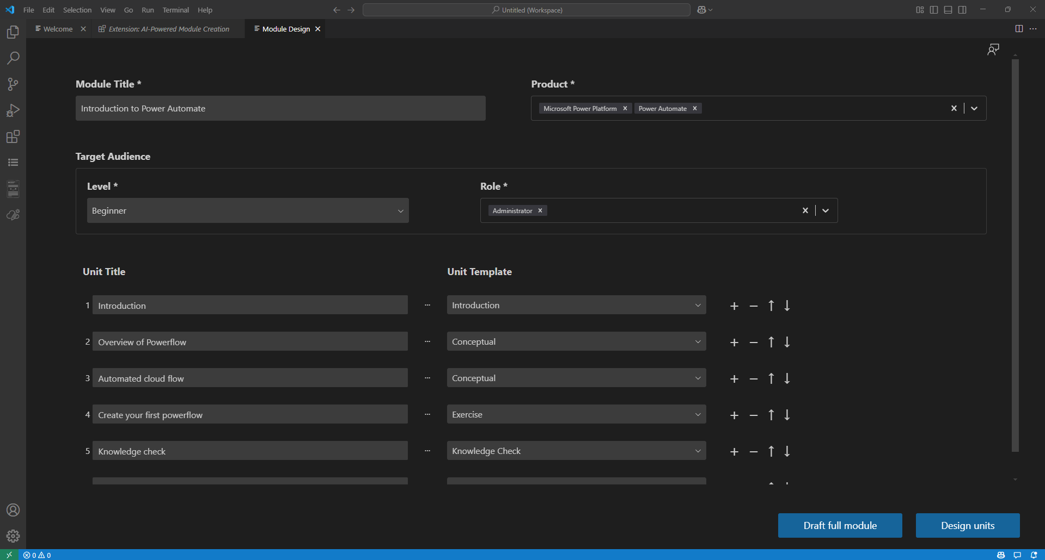

1. Click the **Design Units** button to proceed. You can tell status of each unit from the status icon.

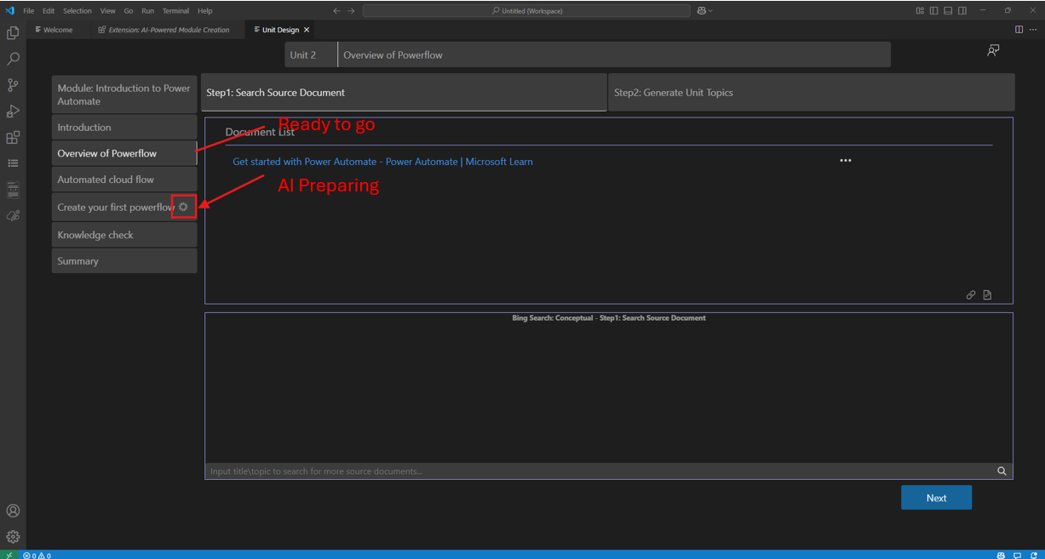

1. Once the directory structure is generated, the system enters Unit Design mode. At the same time, you can see the generated folder and file structure in the left-hand file directory tree. 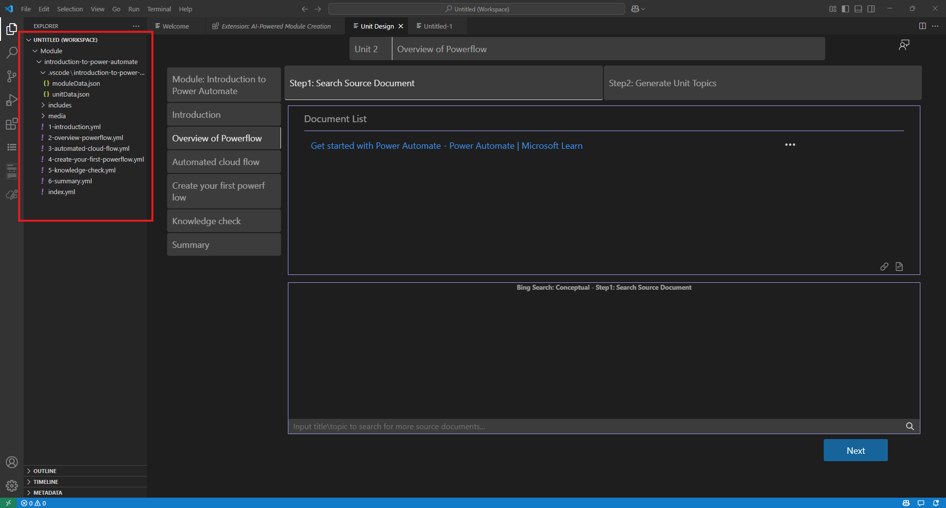

***Note:*** *You can also create a new module from shortcut menu. Right-click the parent folder of module. Select* ***AI-Powered Module Creation*** -> ***Create a new module from scratch****.*

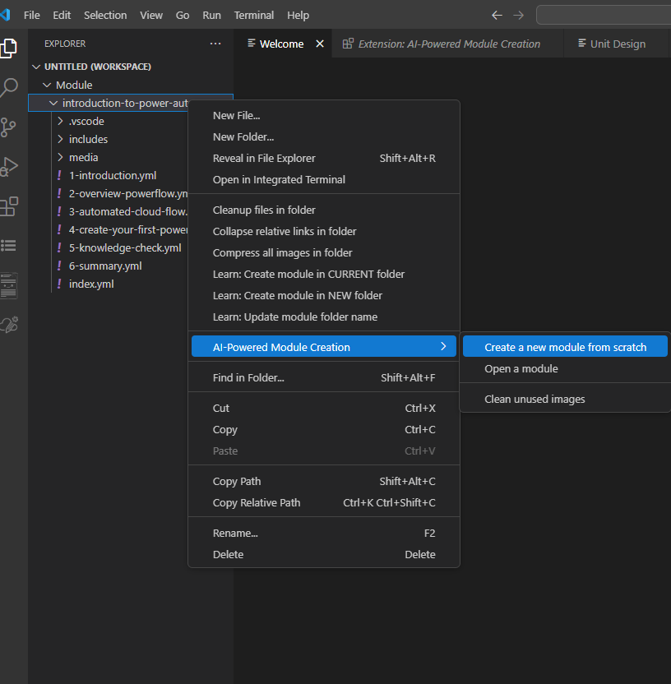

### Open an existing Module

After creating a Module using **AI-Powered Module Creation**, the settings and operations within the Module will be saved. Users can resume their work from the last saved progress by using the **Open a Module** feature to open the existing Module.

1. Click the **AI-Powered Module Creation** button in the tool's sidebar, and then click **Open a Module** in the main interface.

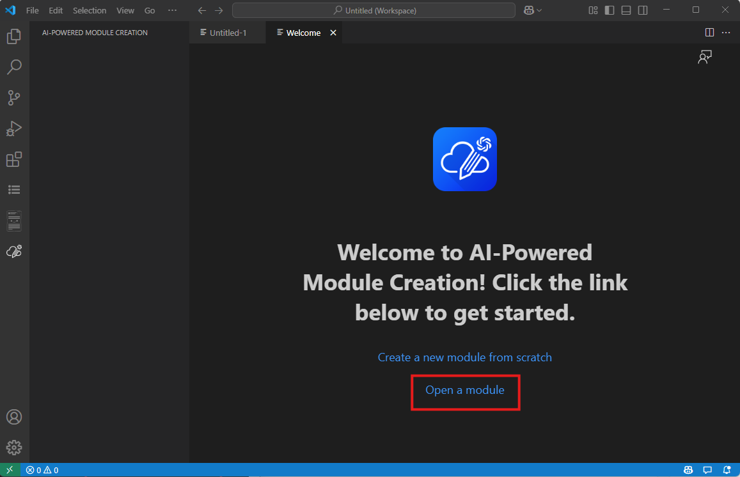

1. In the dialog box, select the **Module directory** and click **Select a folder for the module** to open the module directory.

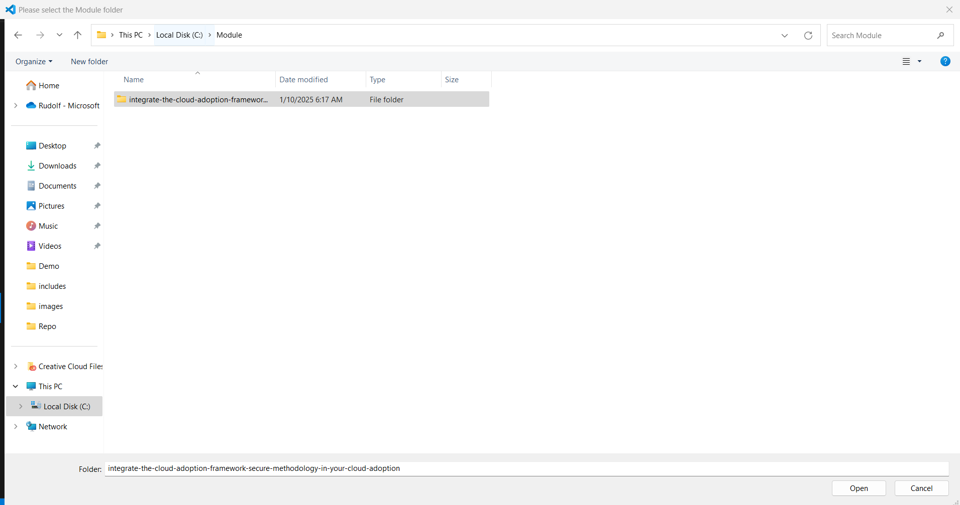

1. This will open the existing Module.

***Note:*** *You can also open a module from shortcut menu. Right-click the parent folder of module. Select* ***AI-Powered Module Creation*** *->* ***Open a Module****.*

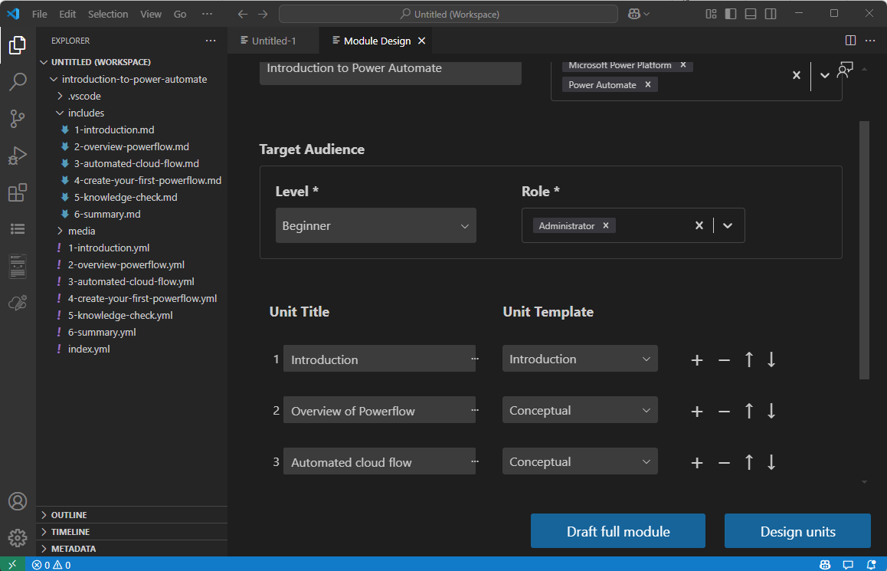

## Module Design

The **Module Design** feature can create the module's file structure based on the user's input for the **Module Design**.

1. Click the **AI-Powered Module Creation** button in the tool's sidebar, and then click **Create a new module from Scratch** or **Open a Module** feature to open the existing Module. You will then enter the **Module Design** interface.



1. Next, the user needs to input the **basic configuration information** for the Module, including:

* **Module Title**
* **Product**: Select the product type that corresponds to your Module's topic. This will help the AI search for content within a precise scope. The product supports search and multiple selection.

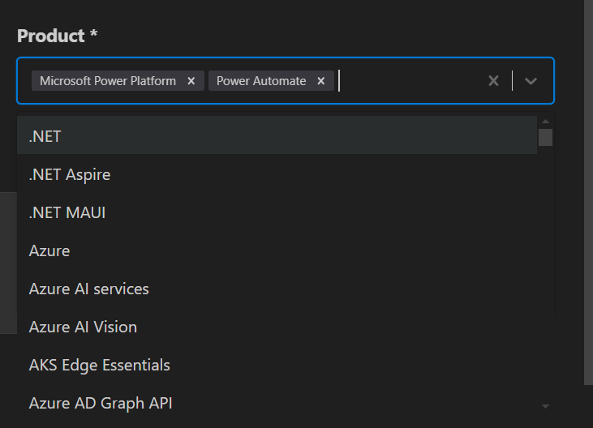

* **Target Audience**: Input the audience profile for the Module. This will help the AI determine whether the retrieved articles match the target audience's level.

1. The next step is to input the Unit information that will be included in the Module.

* **Unit Title**
* **Unit Template**: Here, users can select the **type of Unit** they want to include:
  + **Introduction**: The introduction Unit of the Module.
  + **Conceptual Unit**: Suitable for explaining concepts and knowledge.
  + **Exercise Unit**: The practical or lab Unit of the Module.
  + **Knowledge Check Unit**: The knowledge check associated with the Module.
  + **Summary**: The summary Unit of the Module.

By default, the system will create three **Supplemental Units**: **Introduction**, **Knowledge Check**, and **Summary**. Users only need to add or remove **Conceptual Units** or **Exercise Units** as needed.

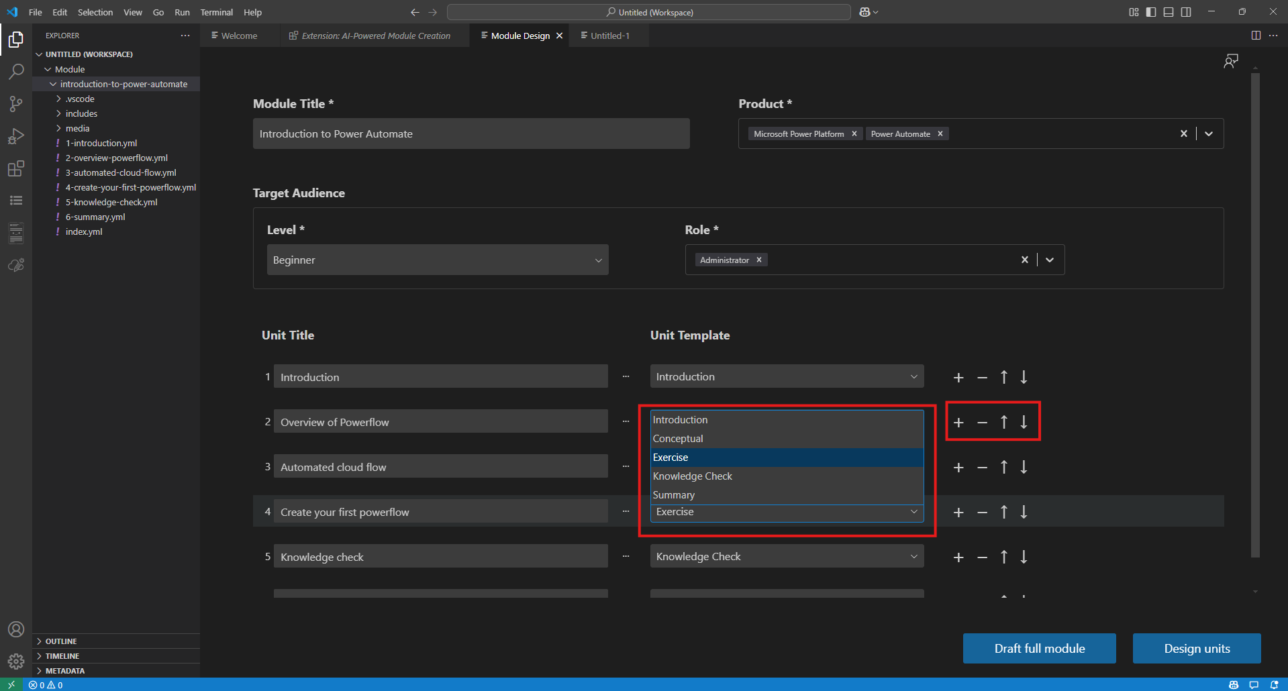

1. Users can use the **+** and **-** buttons to add or remove a Unit. They can also use the **up** and **down** arrows to adjust the order of Units within the Module.

* **Design Units**: This mode allows users to enter a step-by-step Unit creation workflow. This ensures that the generation of your Unit content remains completely under your control, leading to the desired outcome.
* **Draft Full Module**: This mode enables an unattended full Module creation process. The plugin will let the AI autonomously complete the entire Module.  
  *Note: This process may take a significant amount of time. For example, creating a Module with 5 Units can take over 5 minutes.*

## Unit Design

After completing the Module design in **Module Design** function, if the user clicks Design Units, they will enter the **Unit Design** function. Here, users can leverage AI to generate the content for each Unit.

We will explain this process by dividing it into two types: Conceptual Unit and Exercise Unit.

### Conceptual Unit Design

1. Click the **AI-Powered Module Creation** button in the tool's sidebar, and then click **Create a new module from scratch**  to create a new module or **Open a Module** feature to open the existing Module. You will then enter the **Module Design** interface. Click a conceptual unit, then system will enter conceptual unit design wizard.

This process consists of **two steps**:

* **Step 1: Search Source Document**  
  Search for relevant source documents based on the **Unit Title** and **Product**. You need review, add, or customize the documents in the **Document List**.
* **Step 2: Generate Unit Topics**  
  The AI generates suggested **Unit Topics** based on the data sources. You need refine, add, or adjust the topics to align with your design requirements.
* 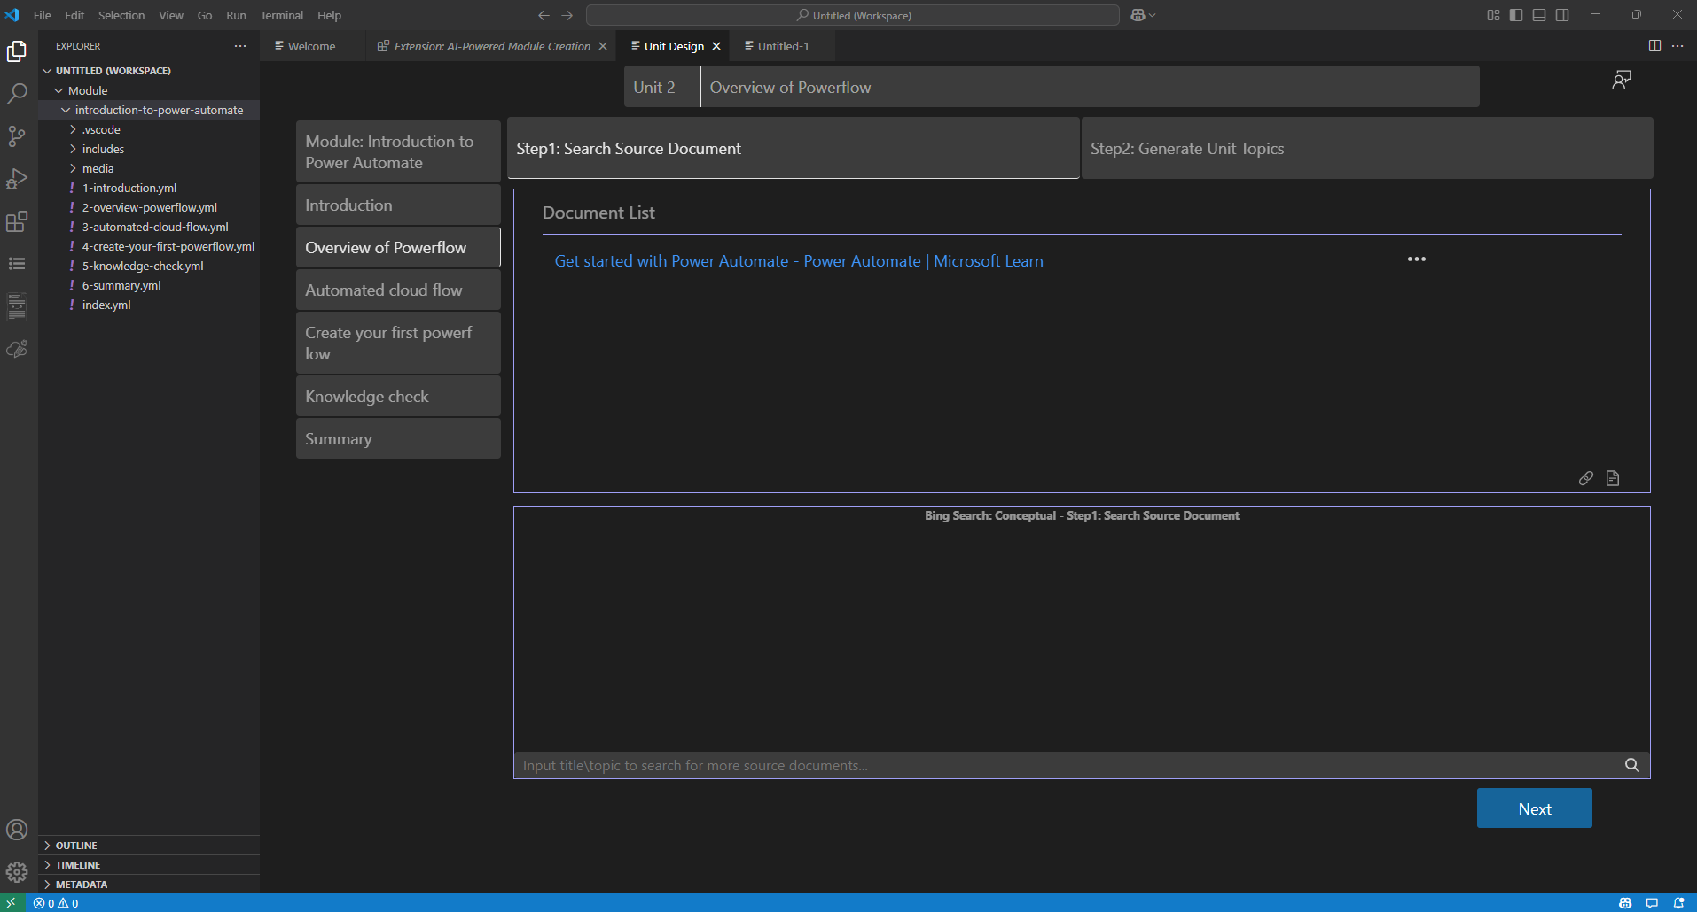

1. **Step1: Search Source Document**  
   When entering a **Conceptual Unit**, the first step is **Search Source Document**. The system will automatically search for relevant articles based on the **Unit Title** and **Product** information and check article relevance against **Target Audience Profile**. These articles are sourced from the Learn website's documentation. The **Unit Designer** will use these articles as Data source to generate the Unit content. Users can click on the articles in the Document List to review whether the content meets their requirements.  
   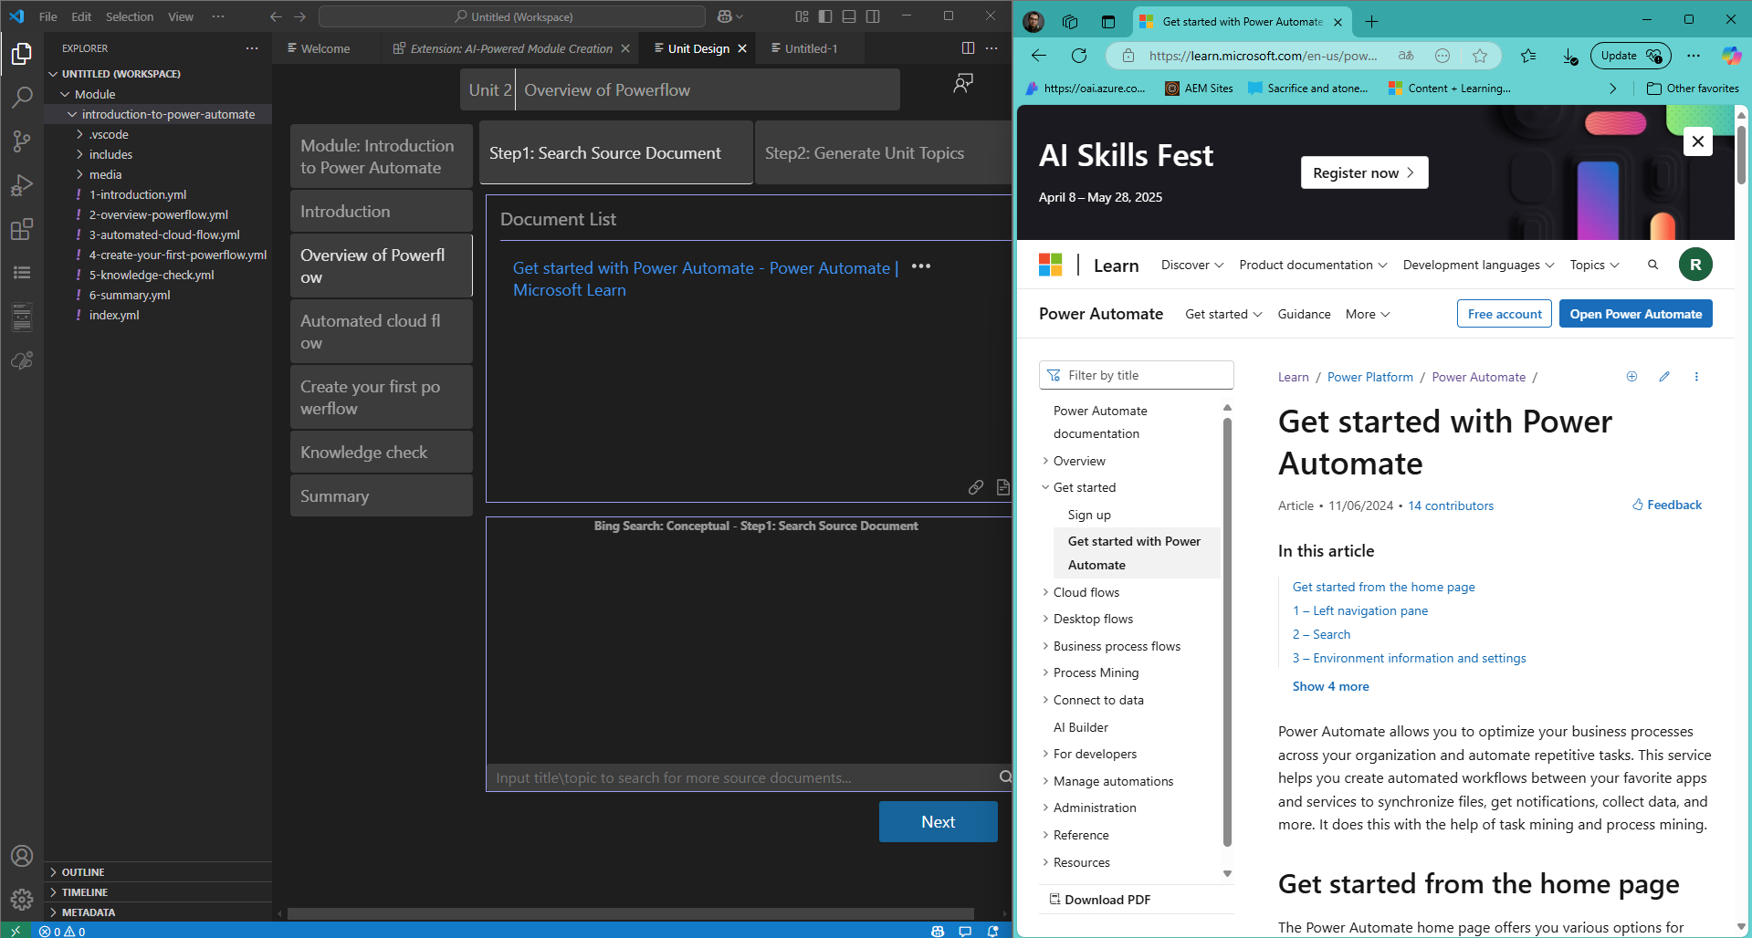

Users can also click on the **...** (ellipsis) next to each article to access additional options, such as previewing, removing the article from the content source.

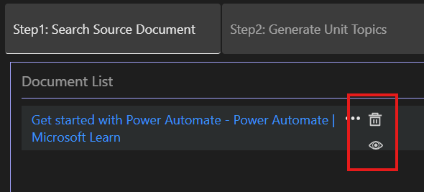

The tool also provides a **Bring Your Own Data** feature, allowing users to provide their own links and documents as a data source.

Users can click the **chain icon** to add a new web link

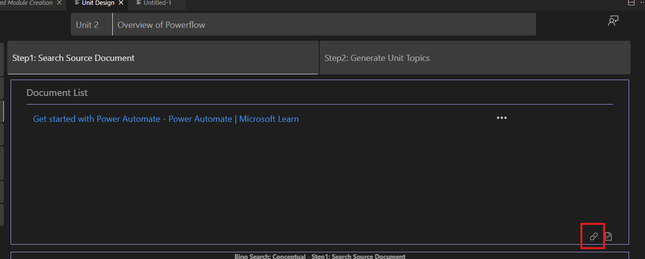

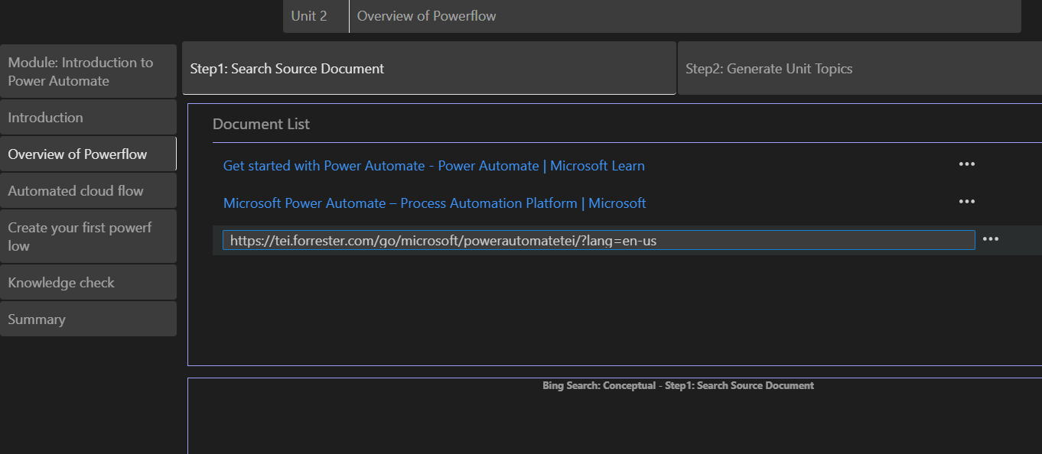

User can also click the **document icon** to select and upload their own documents （.md and .docx）.

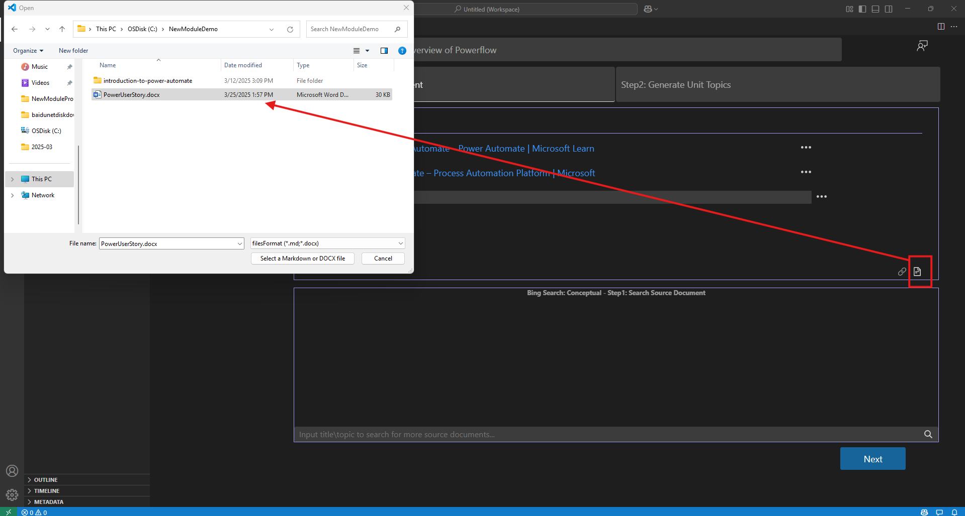

The **AI-Powered Module Creation** extension also provides a search feature. Users can enter keywords into the search box located below the **Document List**, and the system will search for relevant documents on **learn.microsoft.com**. Users can click the link to open the webpage for review. Once confirmed, they can click the **plus icon** to the right of the link to add the article to the **Document List**.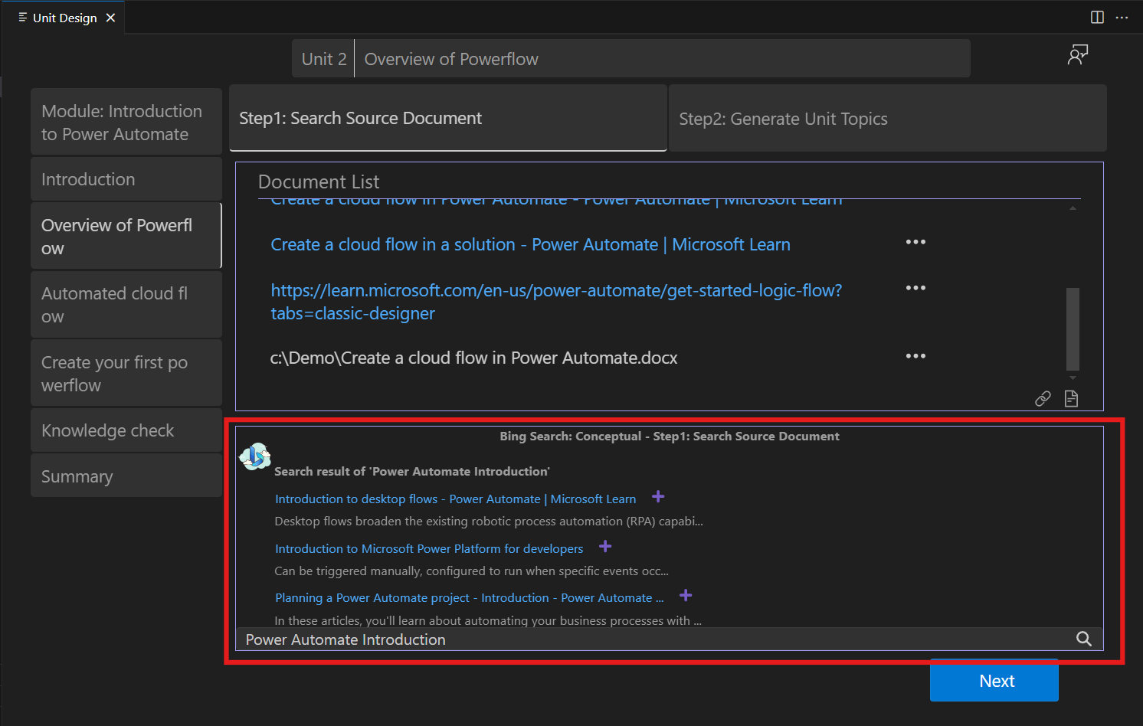

By customizing the **Data Source**, you can precisely define the content source for the Unit.

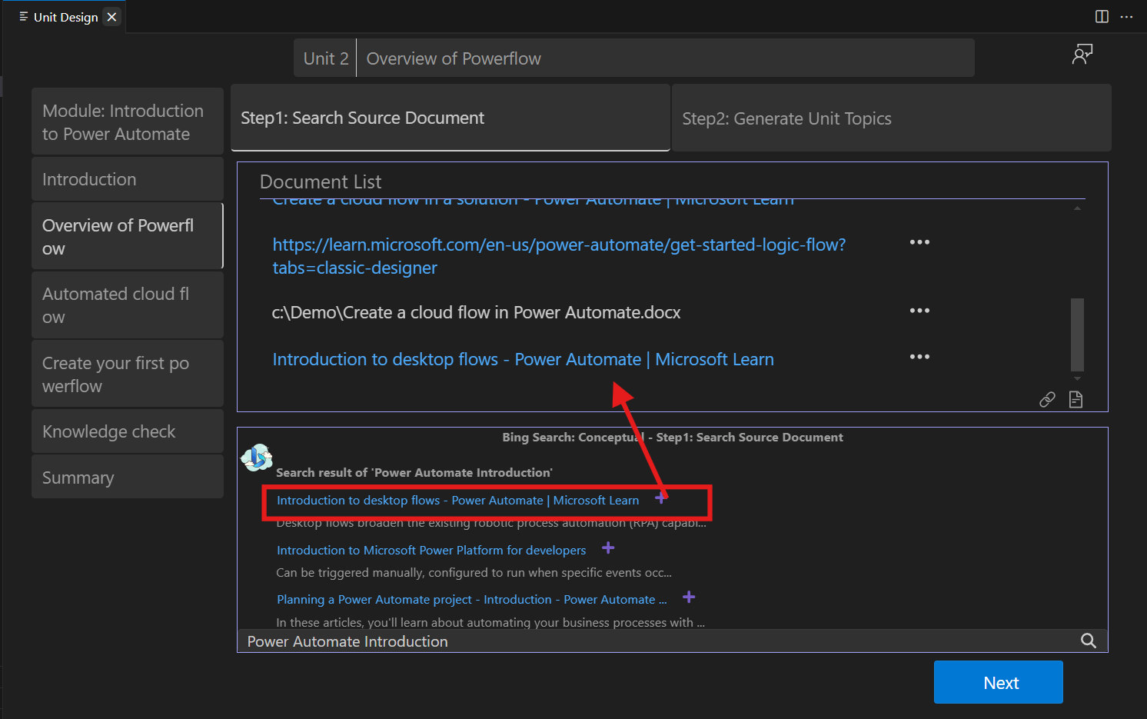

**Note:** When you update Datasource and switch Step 2, system will tell you Document List was updated and do you want to regenerate Unit topics. Since topics are generated from Datasource, system will ask if you want to regenerate topics. You can click “Yes” to regenerate, or you can click “No” to skip this.

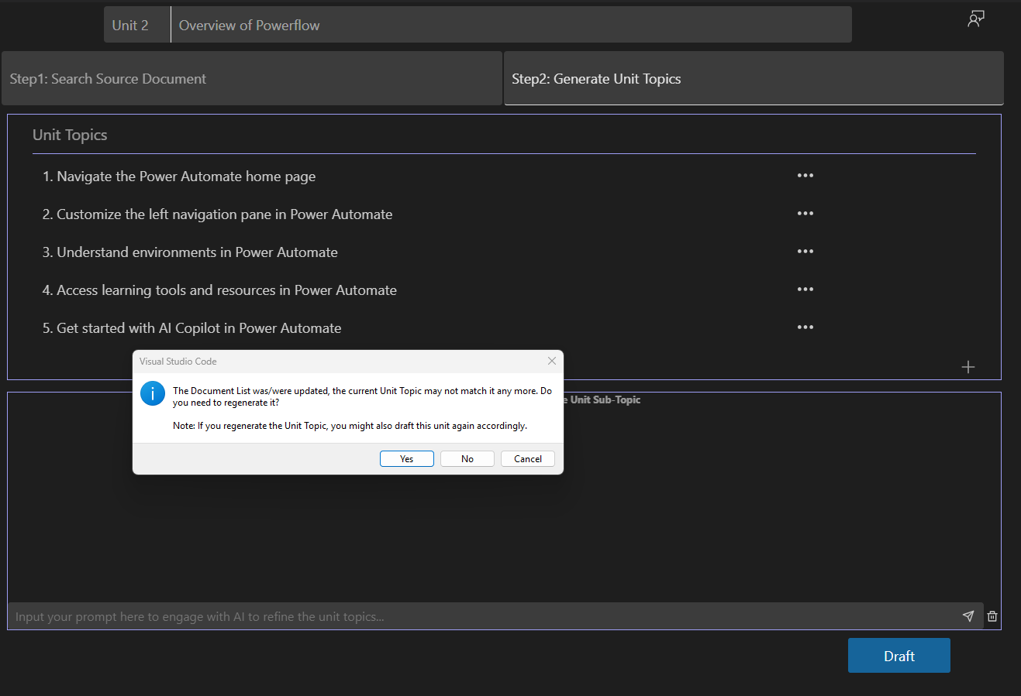

1. **Step2: Generate Unit Topics**  
   Once the data source is defined, the second step is to design the **Topics** included in the Unit. The AI will automatically generate suggested Topics from datasource, but users can adjust and customize them based on their design requirements. The AI will then use these Topics to select relevant content snippets from the specified **Data Source** and create the final Unit content.

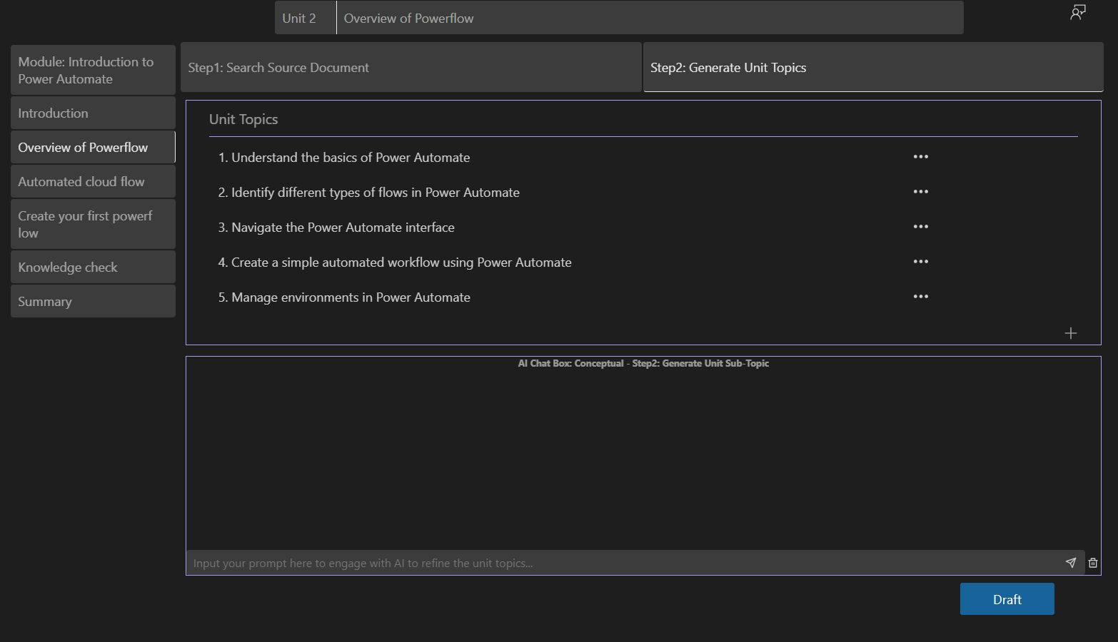

Users can double-click an existing **Unit Topic** to edit its content. Alternatively, they can click the **...** (ellipsis) to open the menu, where they can **delete a Topic**, or move a Topic up or down.And you can add a topic via “+” button at the corner.

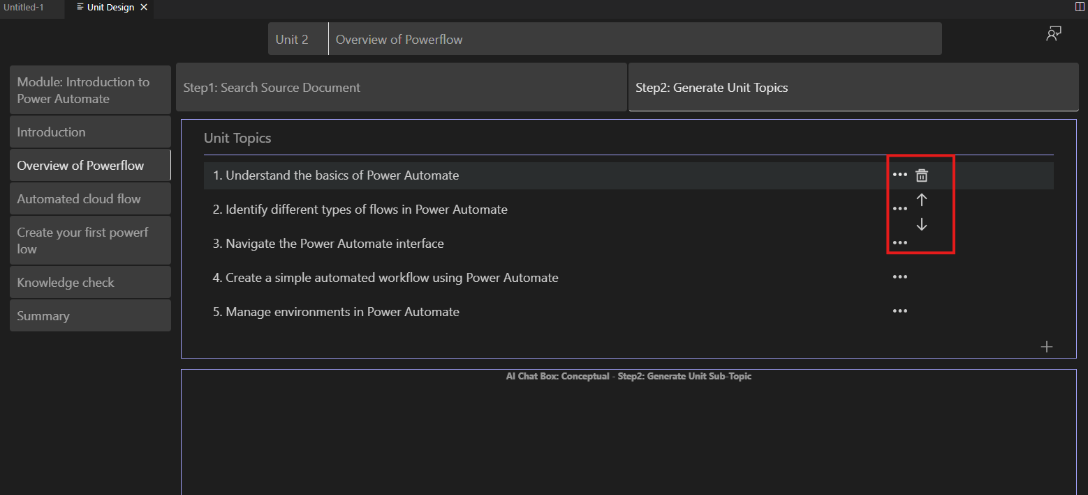

In addition, the **AI-Powered Module Creation** extension provides AI capabilities. Users can enter a **Prompt** in the input box below **Unit Topics**, and the AI will generate content based on the input. This helps users research and identify potential Topics for the Unit.

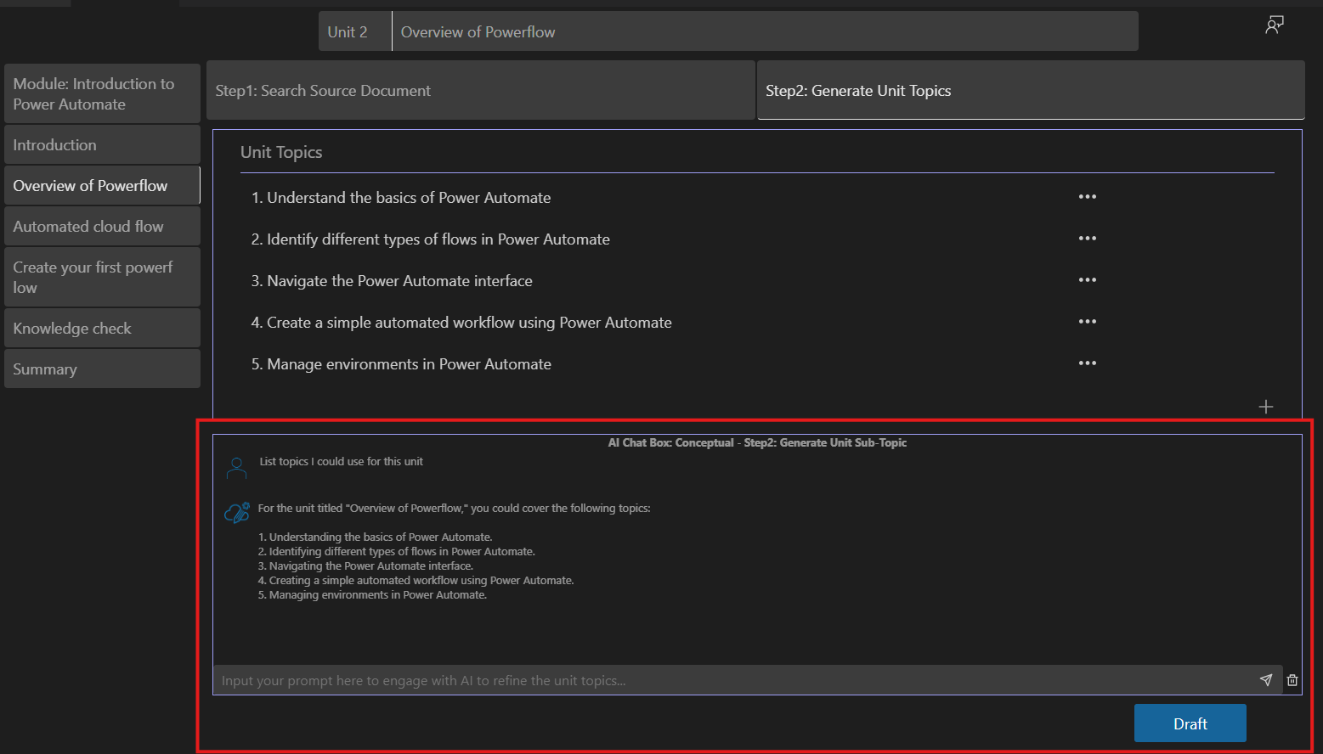

1. After completing Step 1 and Step 2, users can click **Draft**.   
   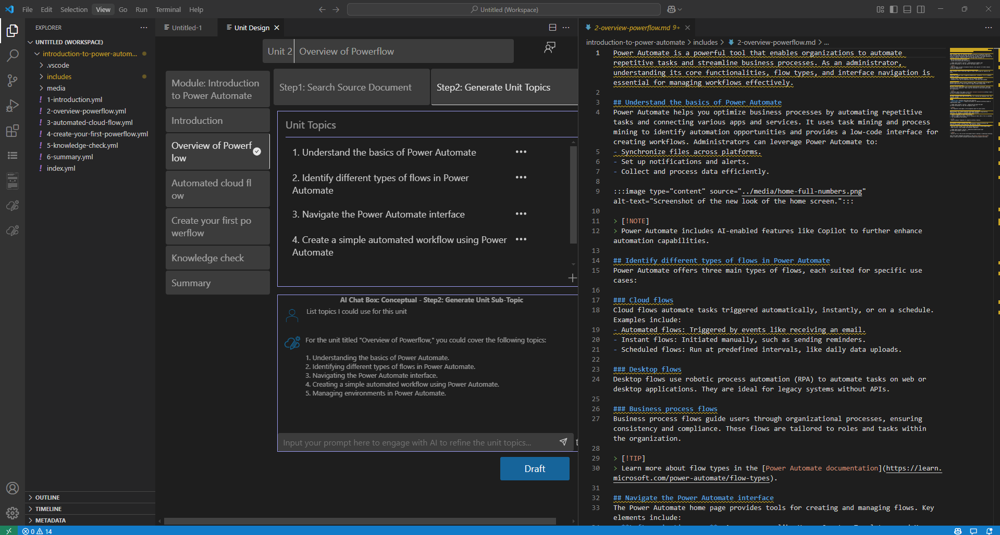  
   And the AI will generate the Unit content. Once the drafting is complete, the system will display the generated Unit in a pop-up window.
2. Once unit is generated, you will see the indicate beside unit title to show this unit is generated.

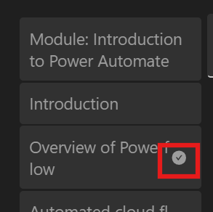

If you are not satisfied with the generated Unit, you can click the **Draft** button multiple times to create different versions.

### Exercise Unit Design

This process of generate Exercise consists of **three steps**:

* **Step 1: Search Source Document**  
  Search for relevant source documents based on the **Unit Title** and **Product**. You can review, add, or customize the documents in the **Document List**. To get ideal experience, Authors could add own data to make content more precise and according to authors requirements.
* **Step 2: Generate Exercise Goal**  
  Define the goals for the exercise. Tool will help generate initial exercise objectives that can be refined based on your requirements.
* **Step 3: Generate Exercise Outline**  
  Tool creates a draft outline for the exercise, providing a structured framework that you can further adjust to meet your needs.

1. **Step 1: Search Source Document**

When entering an **Exercise Unit**, the first step is **Search Source Document**. The system will automatically search for relevant articles based on the **Unit Title** and **Product** information. These articles are sourced from the Learn website's documentation. The **Unit Designer** will use these articles as content sources to generate the Unit content. Users can click on the articles in the Document List to review whether the content meets their requirements.  
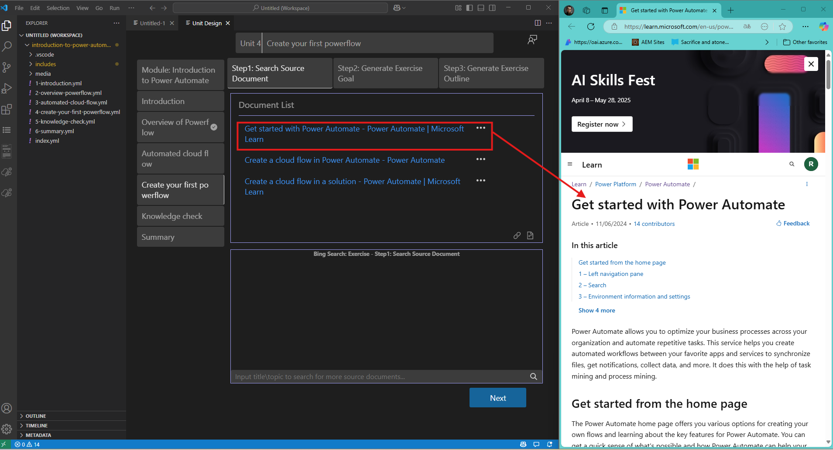

Users can also click on the **...** (ellipsis) next to each article to access additional options, such as previewing, removing the article from the content source.

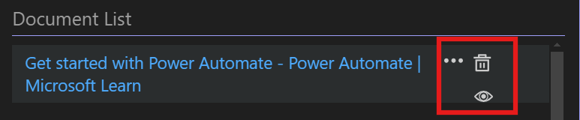

The tool also provides a **Bring Your Own Data** feature, allowing users to provide their own links and documents as a data source.

Users can click the **chain icon** to add a new web link.

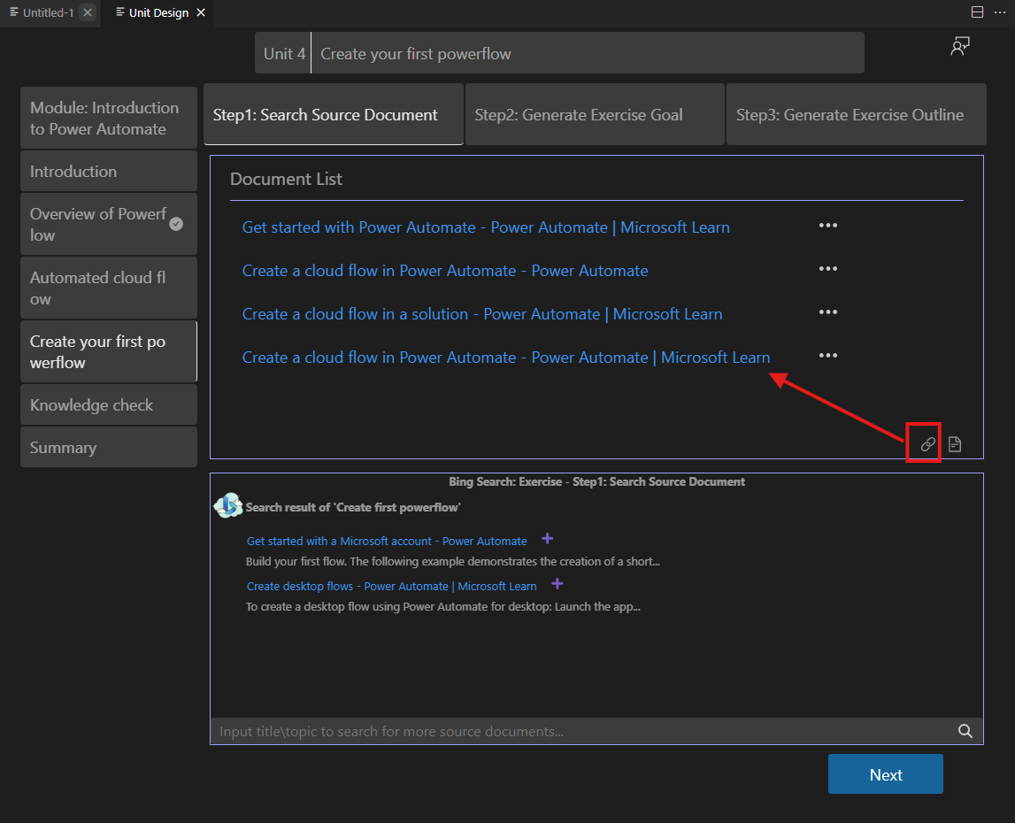

User can also click the **document icon** to select and upload their own documents （.md and .docx）.

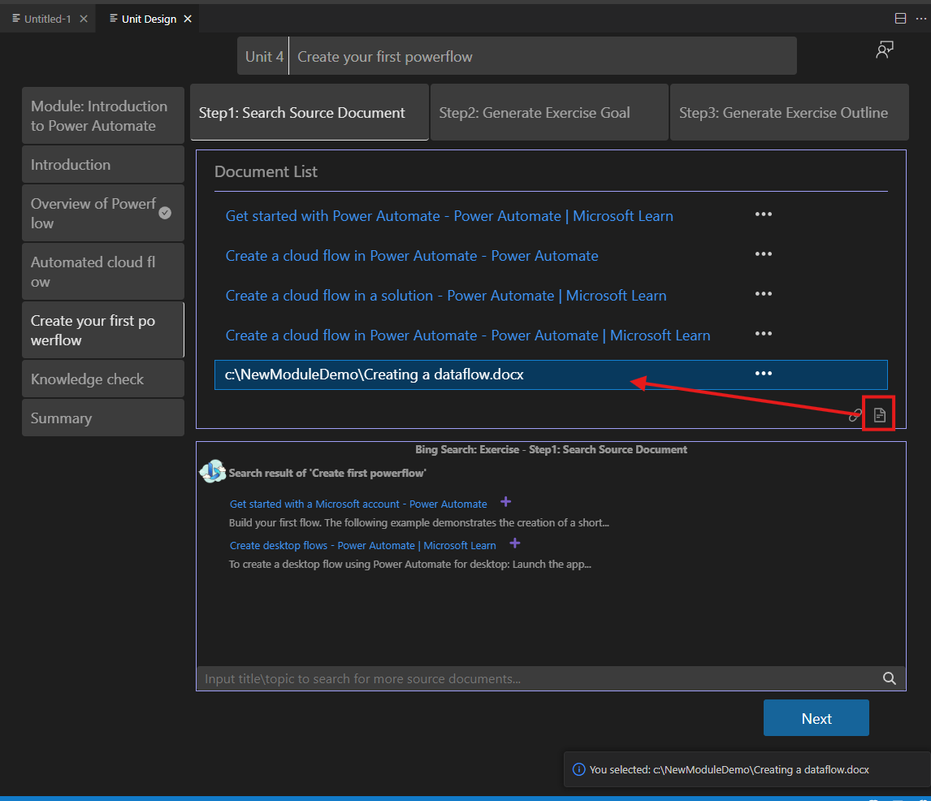

The **AI-Powered Module Creation** extension also provides a search feature. Users can enter keywords into the search box located below the **Document List**, and the system will search for relevant documents on **learn.microsoft.com**. Users can click the link to open the webpage for review. Once confirmed, they can click the **plus icon** to the right of the link to add the article to the **Document List**.

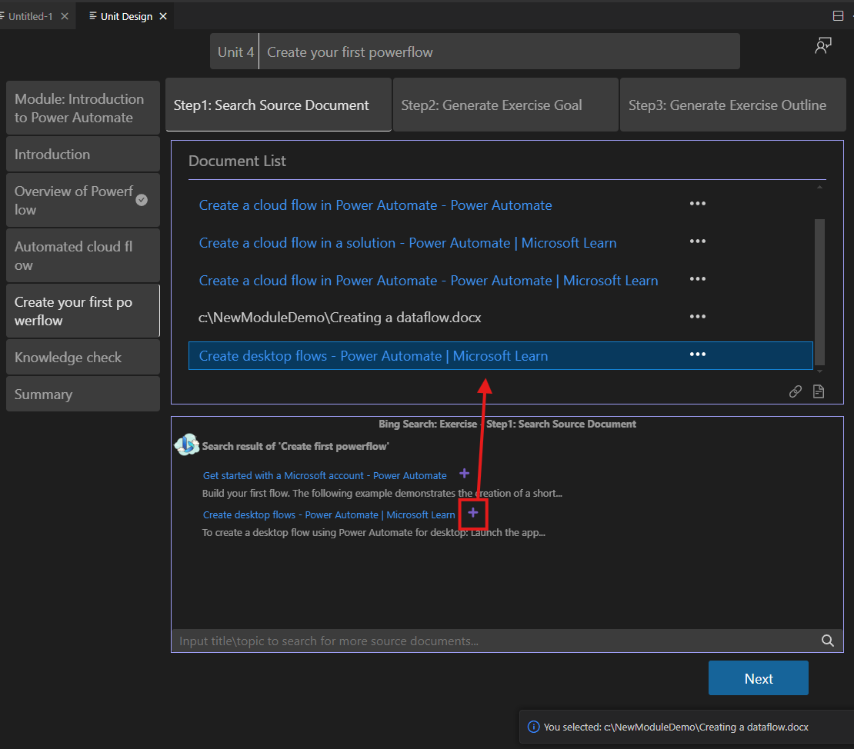

By customizing the **Data Source**, you can precisely define the content source for the Unit.

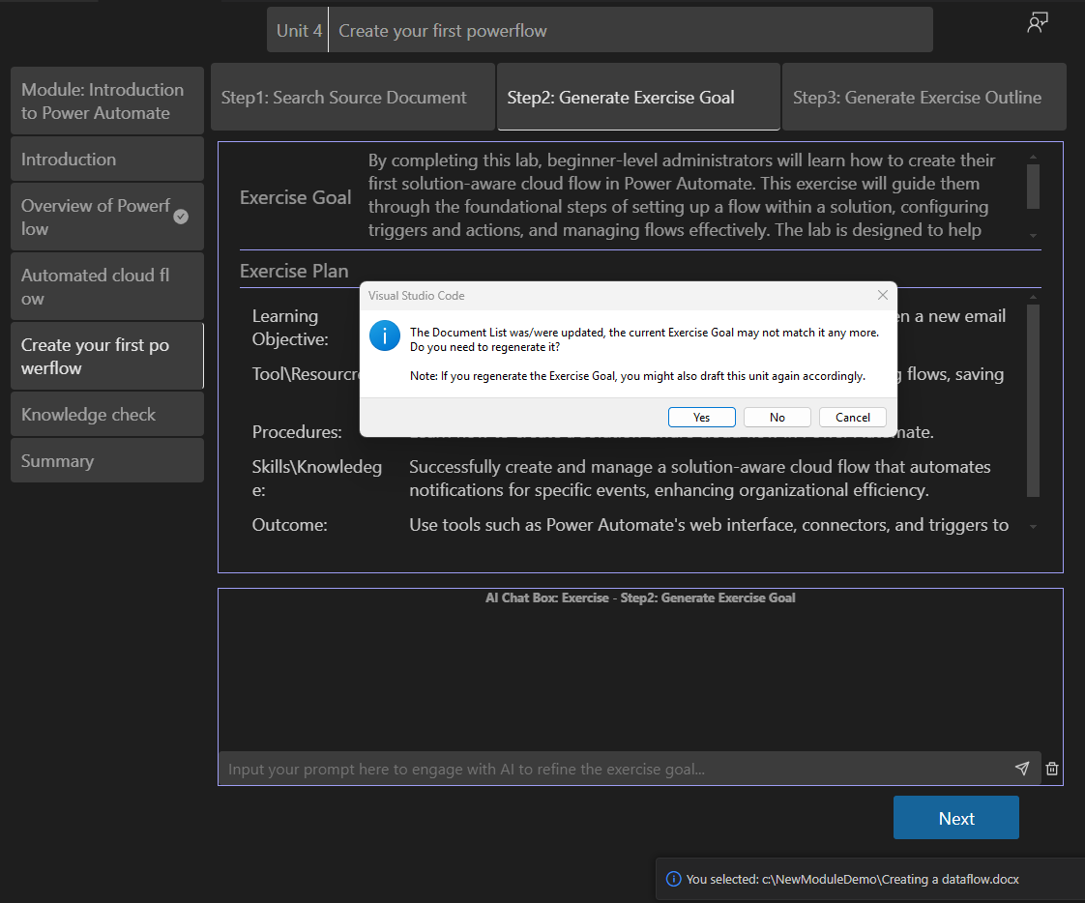

**Note:** When you update Datasource and switch Step 2, system will tell you Document List was updated and do you want to regenerate Exercise Goal. Since Exercise Goal is generated from Datasource, system will ask if you want to regenerate topics. You can click “Yes” to regenerate, or you can click “No” to skip this. This change detect will also happen on step 3 after step 2 changed.

1. **Step 2: Generate Exercise Goal**

The second step is to **set the Exercise Goal**. The system automatically generates the **Exercise Goal** and **Exercise Plan**. Authors can adjust these as needed and use the AI Chatbox below to refine and modify the content.

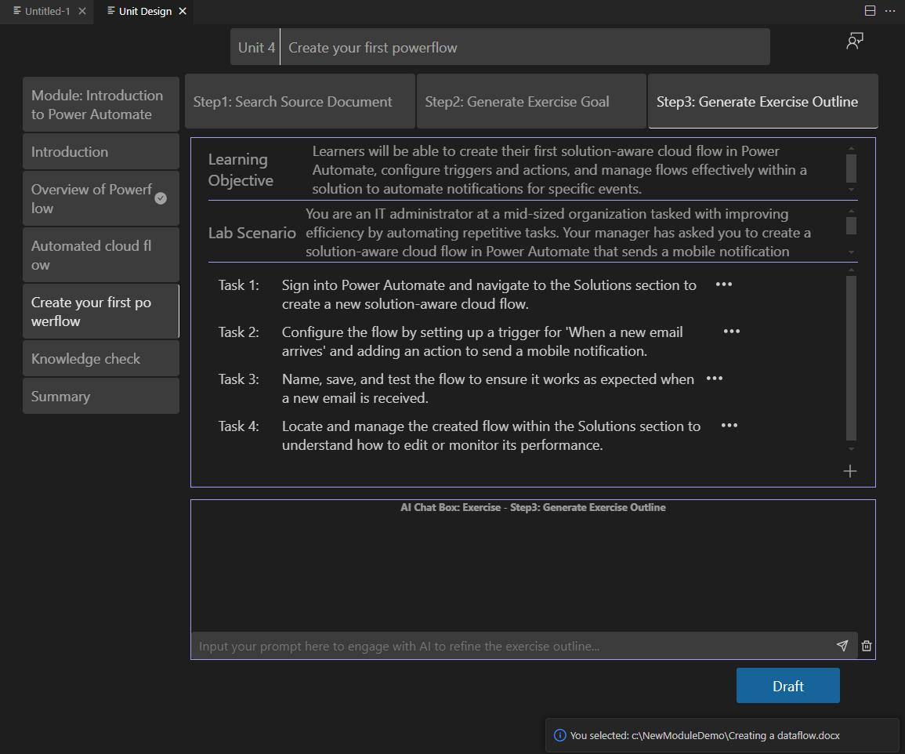

1. **Step 3: Generate Exercise Outline**

The third step is to modify the Exercise Outline. The Exercise Outline specifies the Learning Objective, Lab Scenario, and Tasks. Authors can adjust these elements as needed and use the AI Chatbox below to refine and edit the content. Once all the steps are completed, click **Draft** to generate the exercise steps.

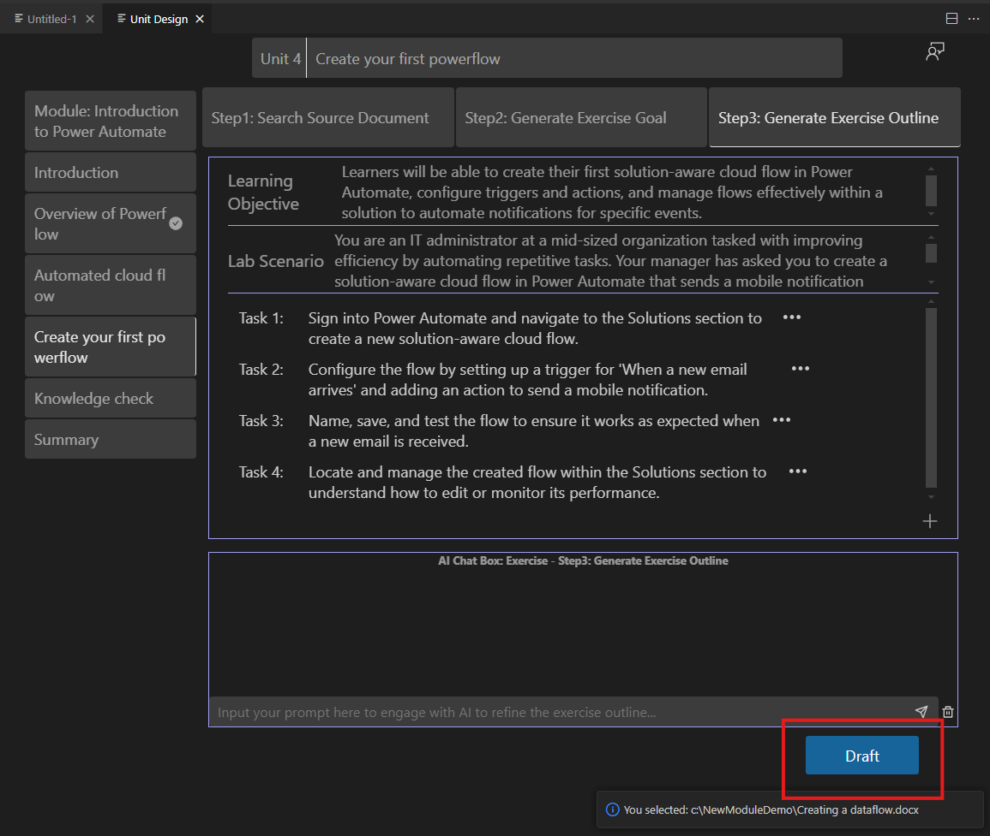

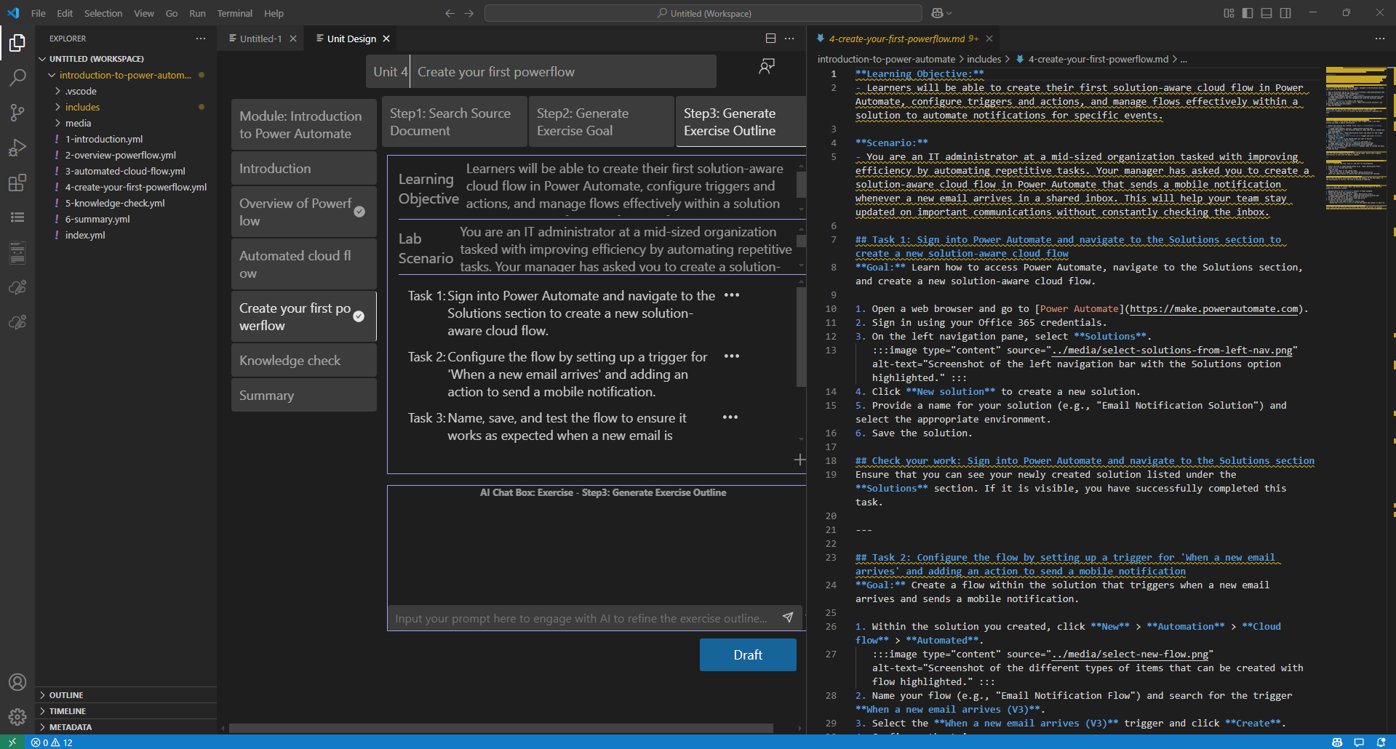

### Supplemental Unit Design

The AI-Powered Module Creation extension provides a one-click generation feature for all Supplemental Units. Once the content Units are completed, you can go to the Introduction, Knowledge Check, and Summary Units, and click the **Draft** button to generate their content.

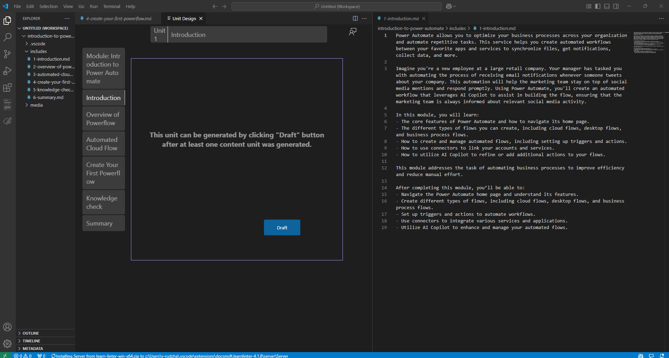

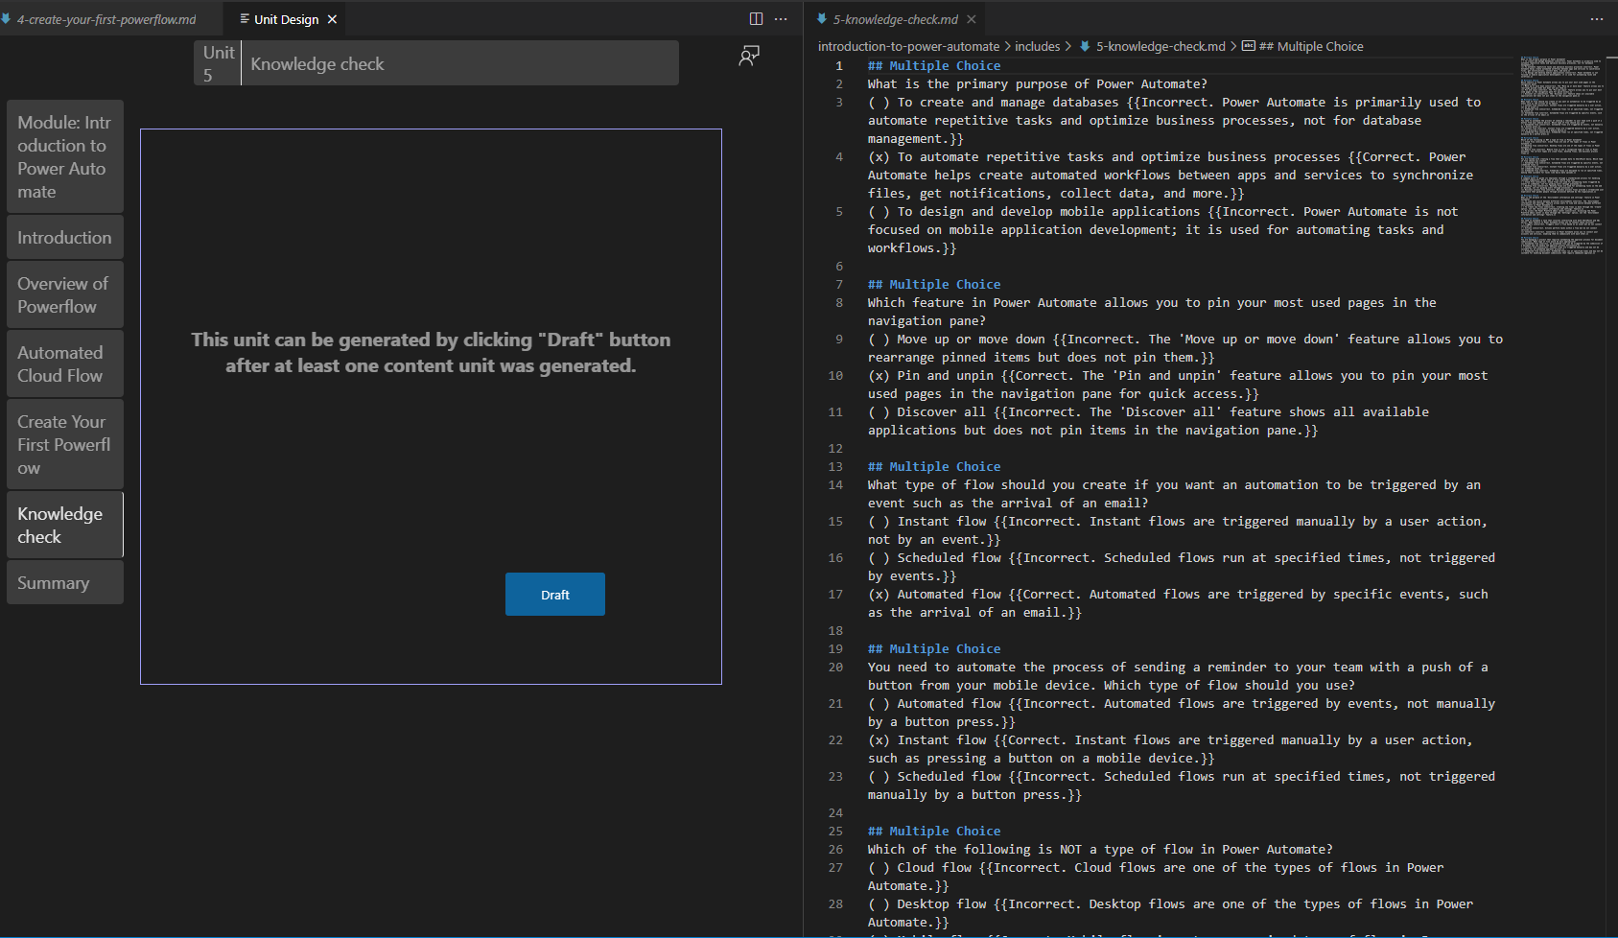

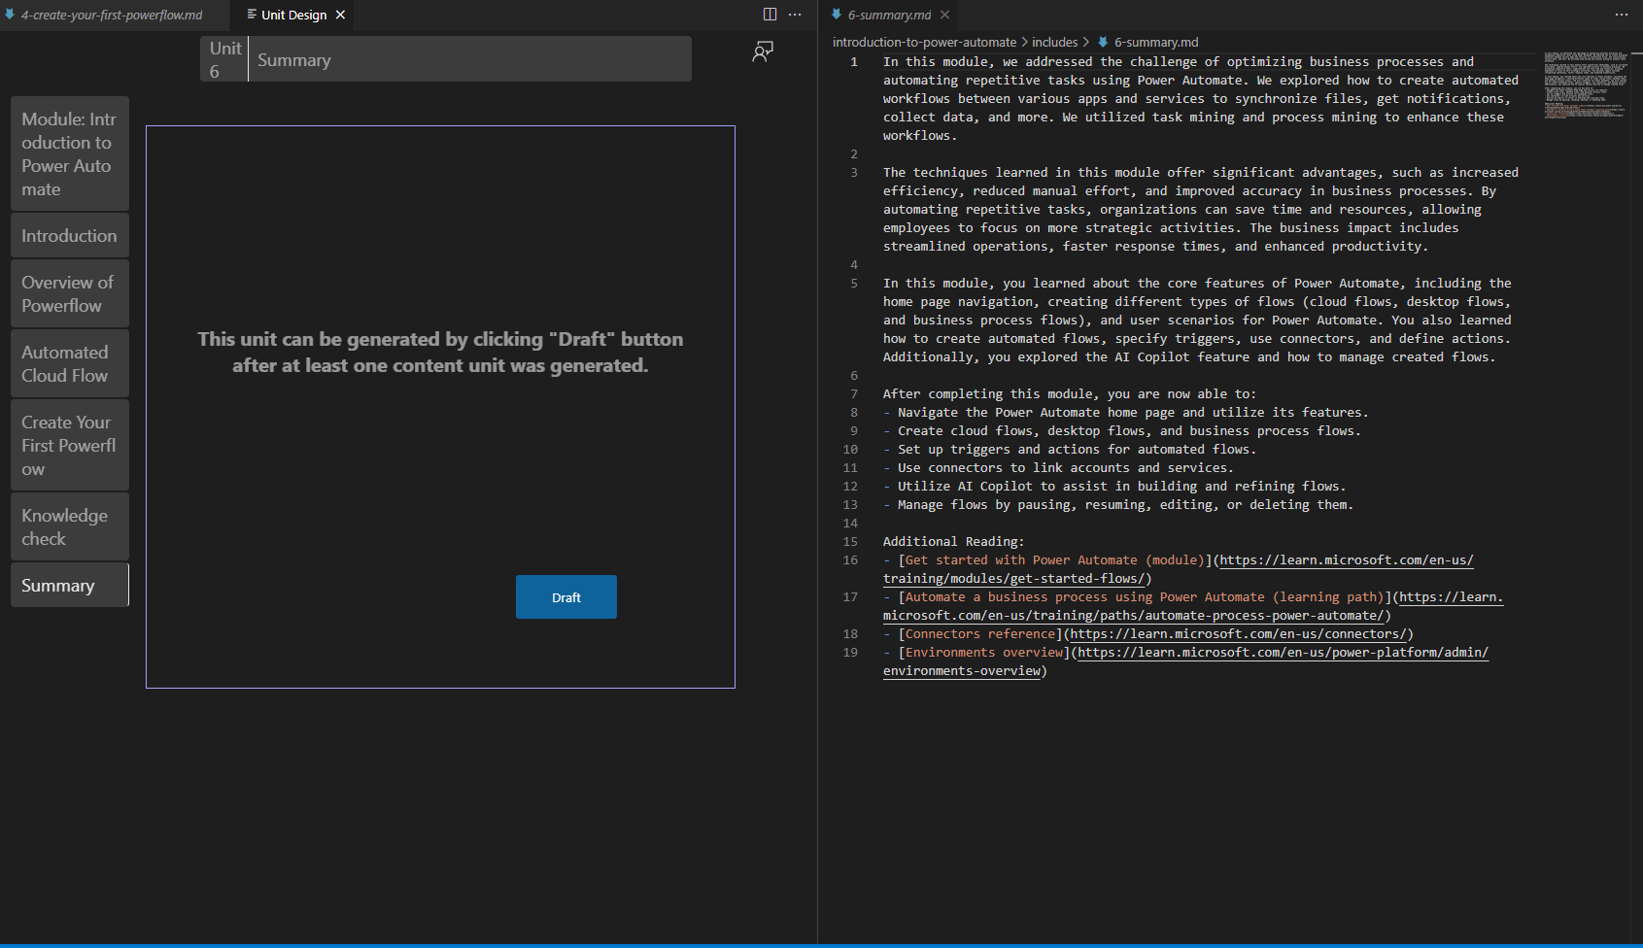

## Content Refine

After using the **AI-Powered Module Creation** extension to draft the Module, users enter the **Content Refine** stage. In this stage, the extension provides three key functionalities:

1. **Content Expansion**  
   Extend the existing content with additional data source, using user’s own prompt to deepen and enrich the Unit.
2. **Content Rewriting**  
   Rewrite or polish existing content to improve clarity, style, and consistency, ensuring high-quality output.
3. **Quick Editing**  
   Access tools for common editing tasks, such as improving **Acrolinx** scores, converting **Learn Image Tags**, and performing other efficiency-boosting edits.

### Content Refine Assistant

The AI-Powered Module Creation extension provides the Content Assistant, an AI-driven tool for content modification. The following sections introduce the key options available in the Content Assistant.

### Add content

**Add Content** allows users to leverage their own provided content and use AI to enrich and enhance the Unit.

1. Right-click on the section of the unit where you want to expand the content. From the menu, select **Content Refine Assistant** -> **Add Content**.

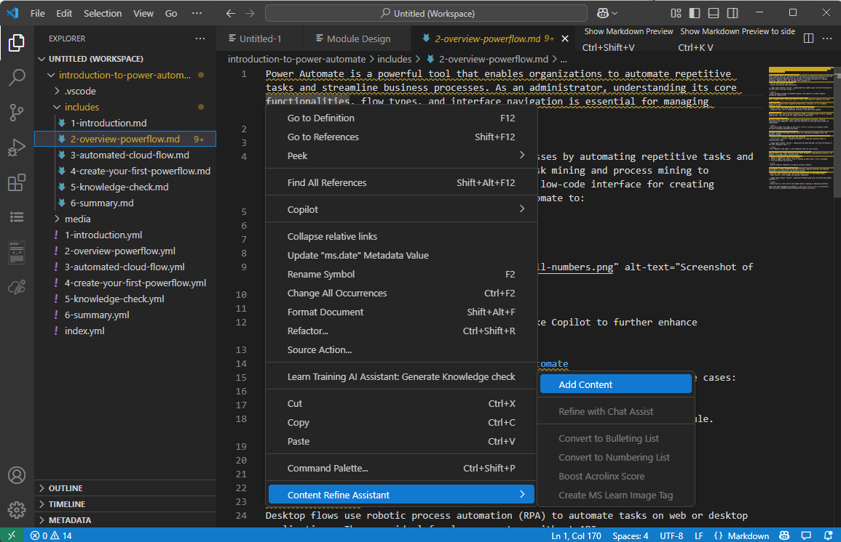

1. In the pop-up dialog box, click **Please input your own prompt to add content.** to initiate the content generation process.  
   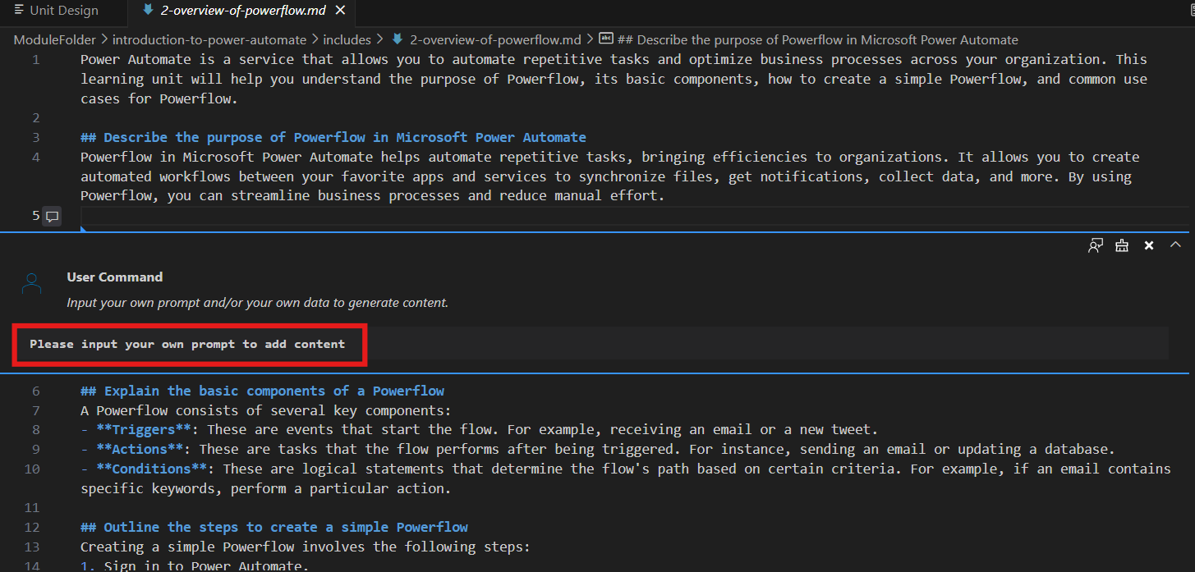
2. In the dialog box, click **Add File** to upload a document that the AI can use as a reference for generating content.  
   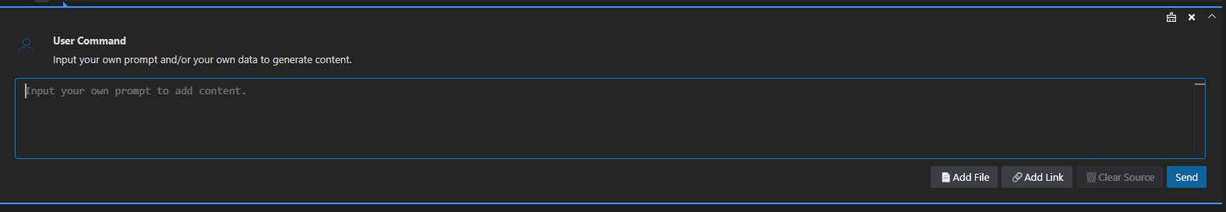

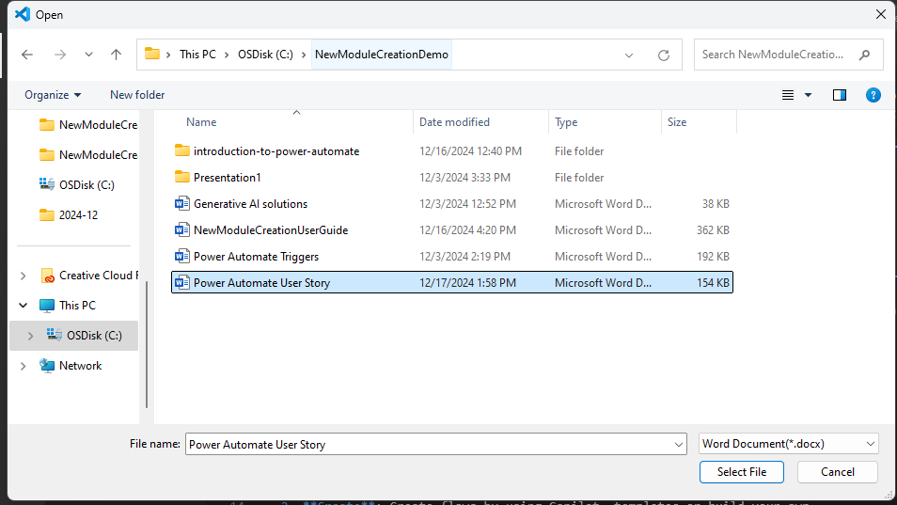

1. Click **Please input your own prompt to add content. You can see document attached.** If you need to clear the document, click the broom icon in the top-right corner. Enter a Prompt as needed to specify the operation you want the AI to perform on the document. You will see result in output.

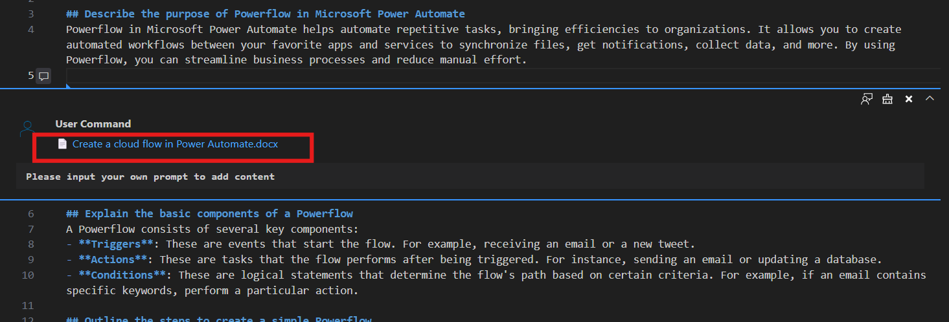

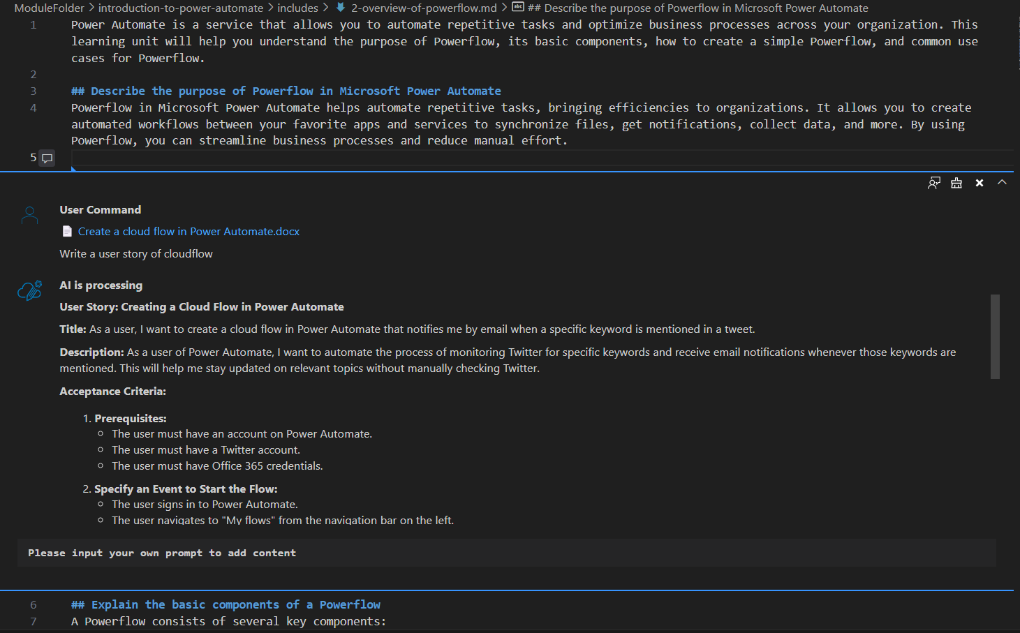

1. Click the **...** (ellipsis) in the top-right corner of the conversation. Select **Insert** to insert the AI-generated content into the document, completing the content expansion. Alternatively, select **Copy** to copy the conversation content to the clipboard.

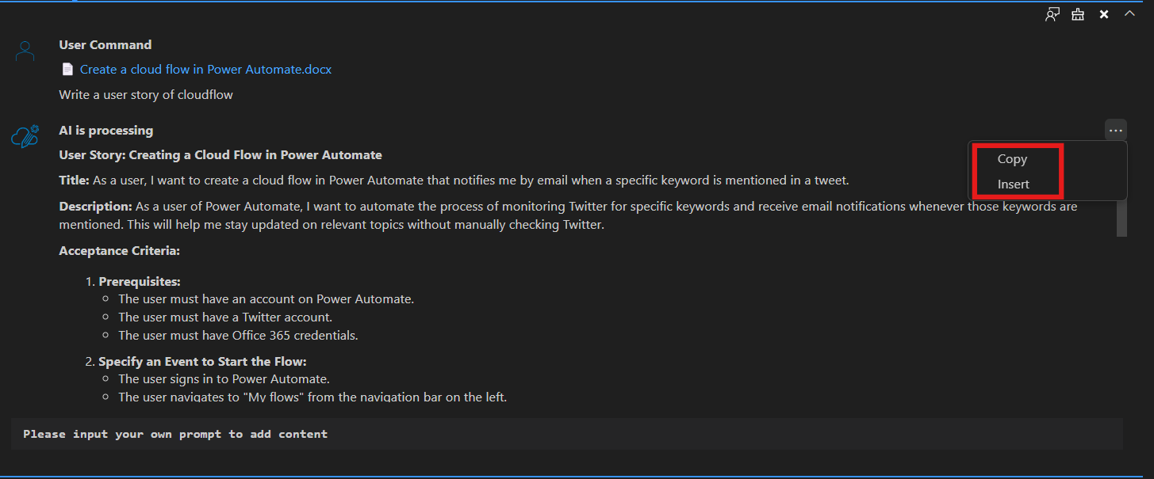

1. In addition, you can use an external **URL** as a data source to further enhance the Unit content. Right-click on the section of the document where you want to expand the content. From the menu, select **Content Refine Assistant** -> **Add Content**. In the pop-up dialog box, click **Please input your own prompt to add content** to initiate the content generation process.
2. In the dialog box, click **Add Link** to add an external URL as a data source for enhancing the Unit content.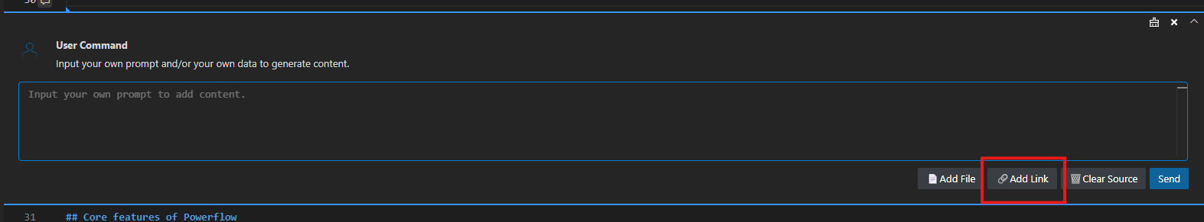

In the **Insert URL** dialog box, enter the link for the external URL you want to use as a data source.

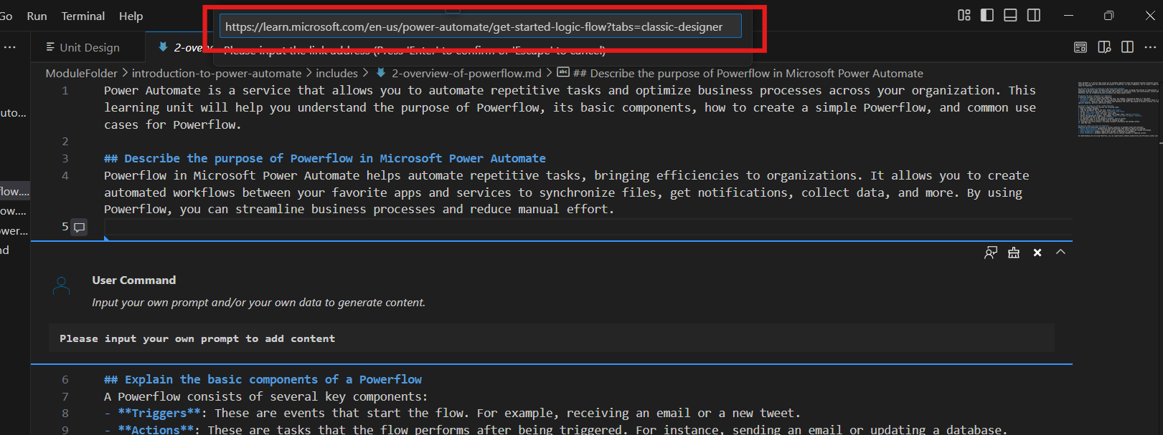

1. You will see the link added to the **Content Refine Assistant**. 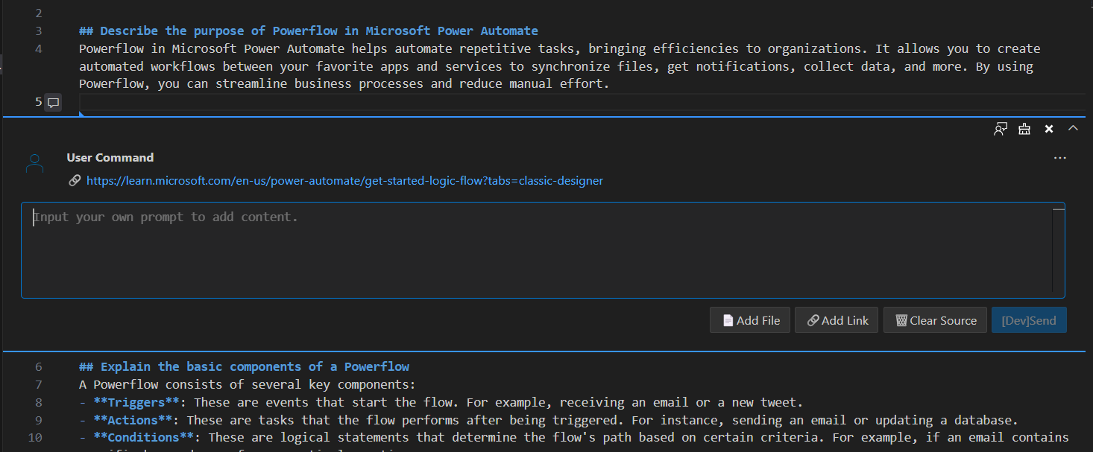

Enter your own **Prompt** and click **Send**. The AI will generate content based on your request. Click the **...** (ellipsis) in the top-right corner of the conversation. Select **Insert** to insert the AI-generated content into the document, completing the content expansion. Alternatively, select **Copy** to copy the conversation content to the clipboard.

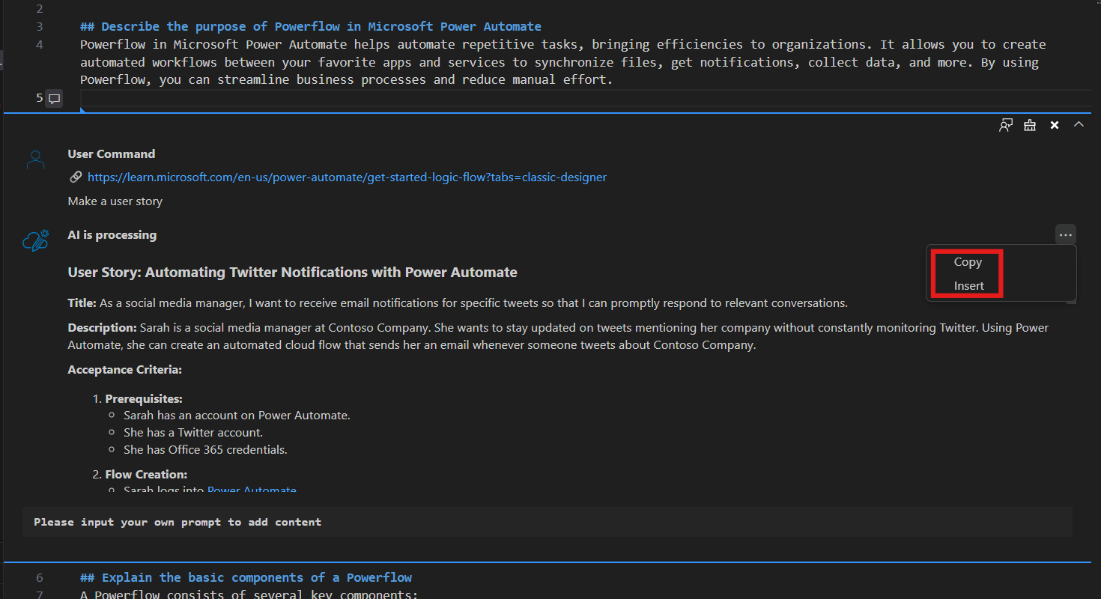

### Refine select content

**Refine Selected Content** allows users to modify and adjust the selected content using a custom **Prompt**.

1. Select the text, right-click, and choose **Content Refine Assistant** -> **Refine with Chat Assist**.

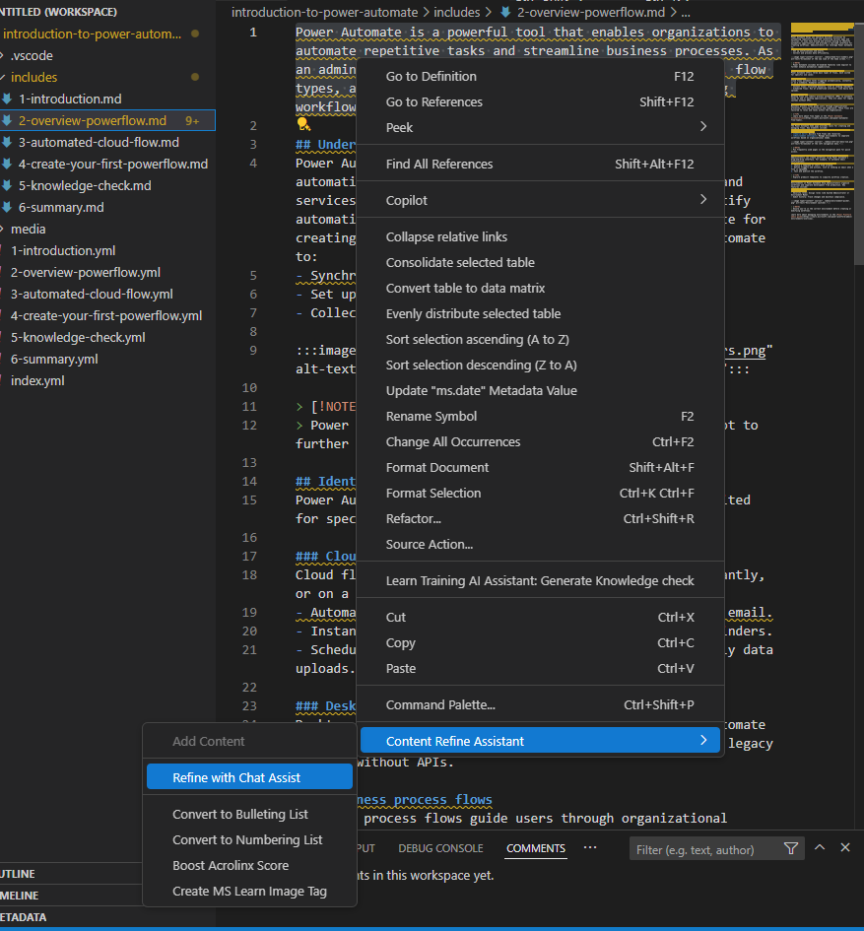

1. In the pop-up dialog box, click **Input your prompt to refine the selected content** to initiate the content generation process.

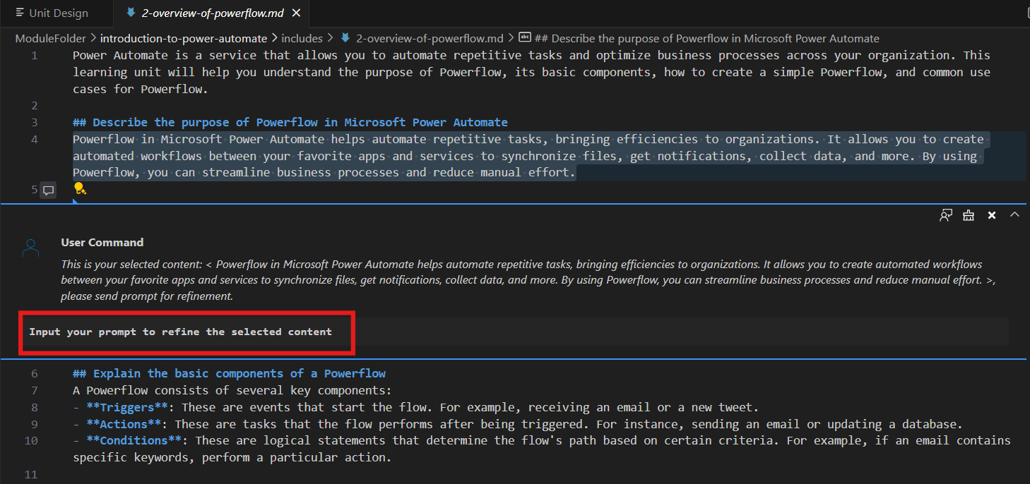

1. Input **Prompt**. Click **Send**.

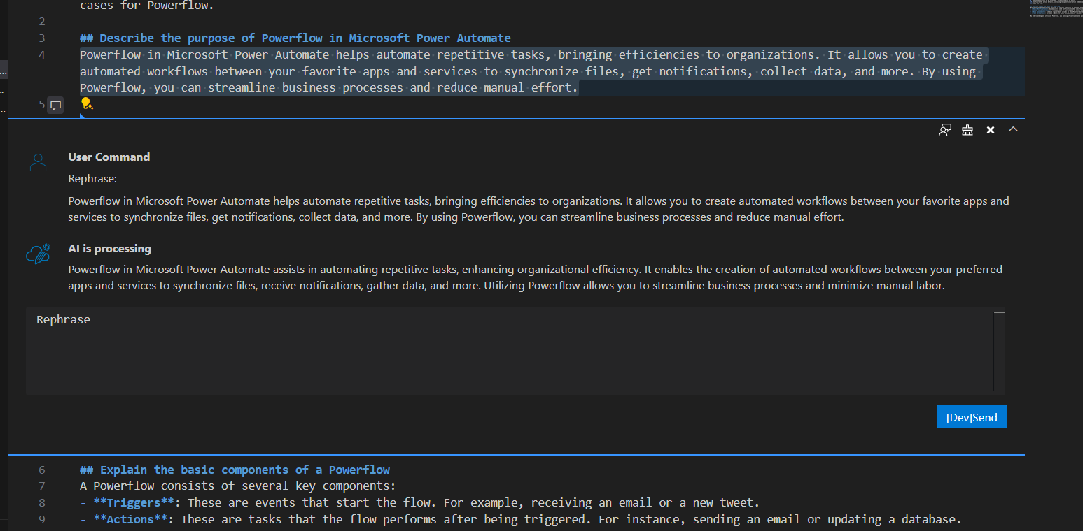

1. Click AI response and click on the **...** (ellipsis). Select **copy** to copy response in memory or click **Replace** to replace selected content in Unit.

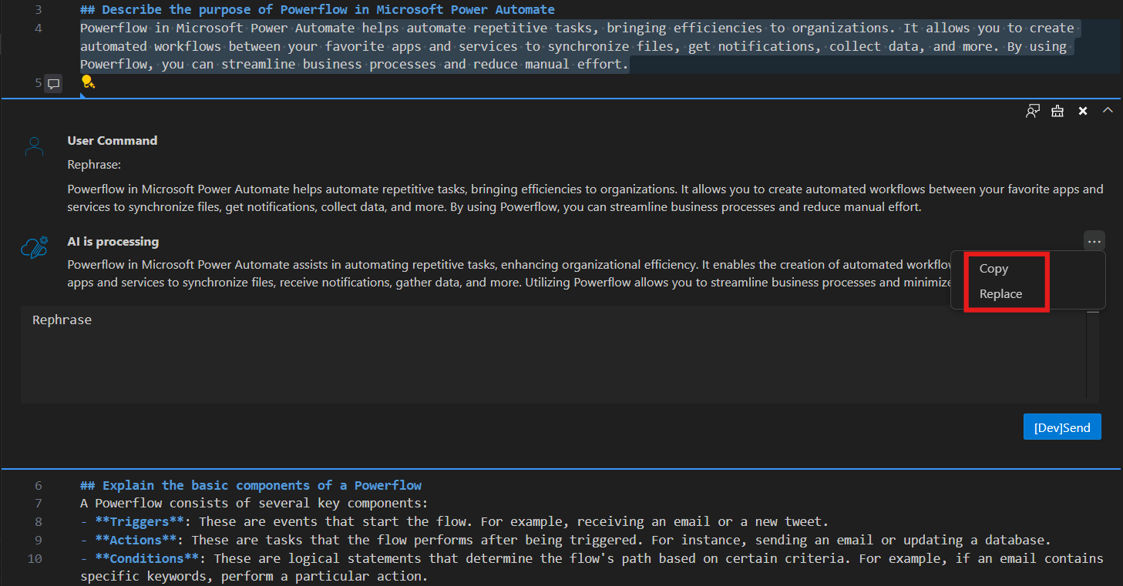

### Clean Unused Images

During the authoring process, unused images will exist under media folder. Those images are not used in any MD files. **Clean unused images** will help resolve those issues.

Right lick Module folder, select **AI-Powered Module Creation**->**Clean Unused Images**.

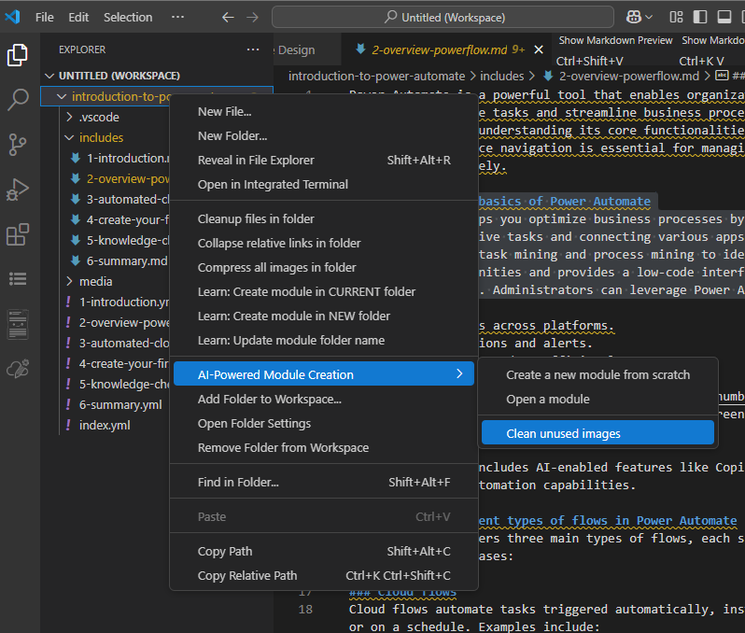

After this process, all unused images will be cleaned.

### Boost Acrolinx

Boost Acrolinx will leverage AI to help improve Acrolinx score of select content.

1. Select the text, right-click, and choose **Content Refine Assistant** -> **Boost Acrolinx Score**.

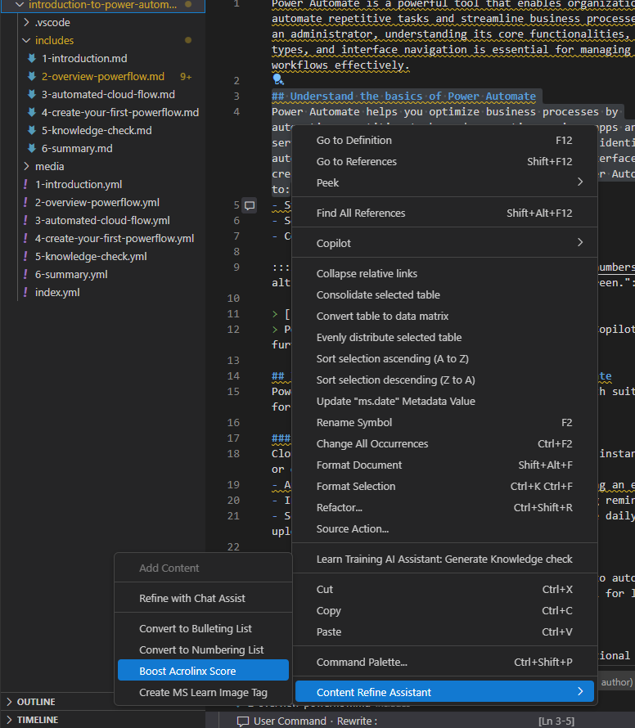

1. Select AI Response, Click AI response and click on the **...** (ellipsis). Select **copy** to copy response in memory or click **Replace** to replace selected content in Unit.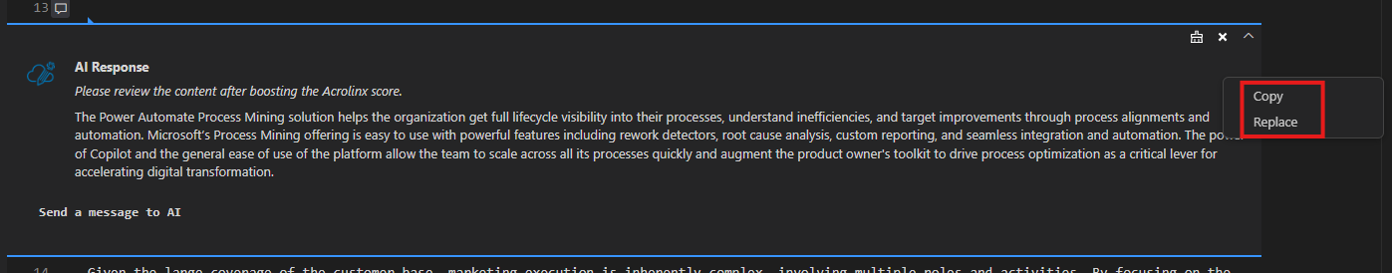

### Create MS Learn Image Tag

Create MS Learn Image Tag will convert image name in code into MS Learn Image Tag.

1. Select the image name in Unit. (For example, “../media/Power Automate User Story.png” ), right-click, and choose **Content Refine Assistant** -> **Create MS Learn Image Tag**.

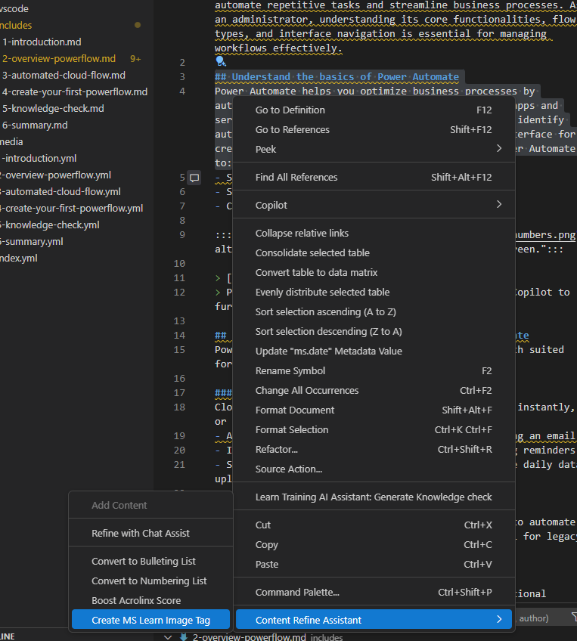

1. Select AI Response, Click AI response and click on the **...** (ellipsis). Select **copy** to copy response in memory or click **Replace** to replace selected content in Unit.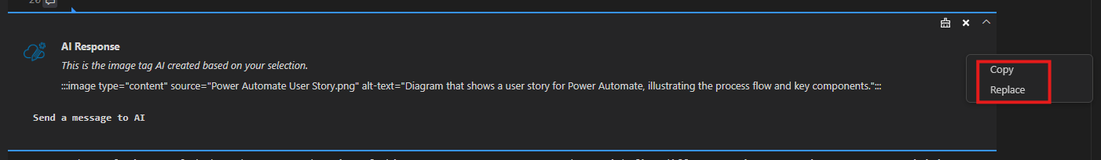

### Update to bullet list

1. Select the text, right-click, and choose **Content Refine Assistant** -> **Convert to Bulleting List**.

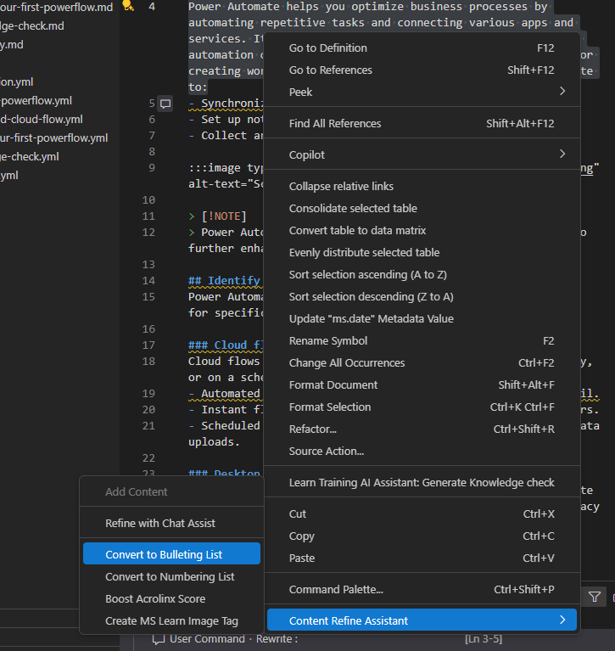

1. Select AI Response, Click AI response and click on the **...** (ellipsis). Select **copy** to copy response in memory or click **Replace** to replace selected content in Unit.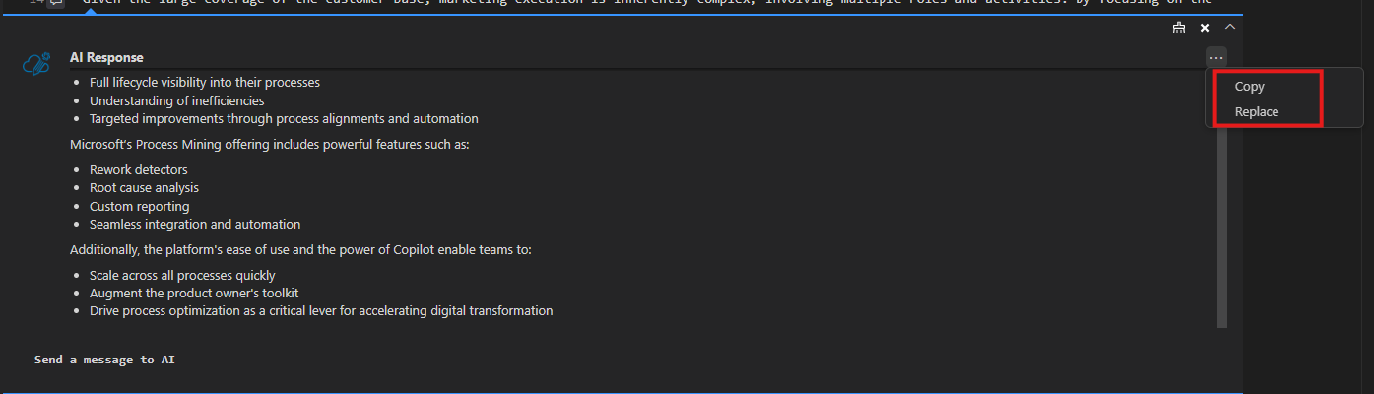

### Update to Numbering list

1. Select the text, right-click, and choose **Content Refine Assistant** -> **Convert to Numbering List**.

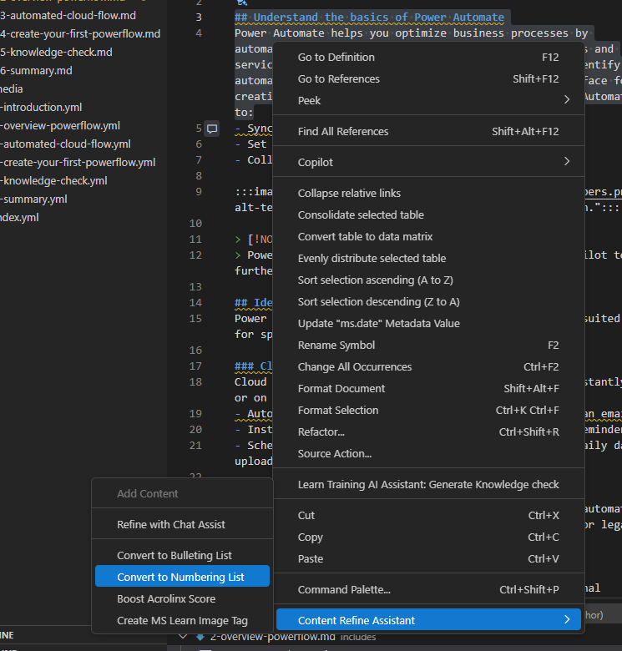

1. Select AI Response, Click AI response and click on the ... (ellipsis). Select **copy** to copy response in memory or click **Replace** to replace selected content in Unit.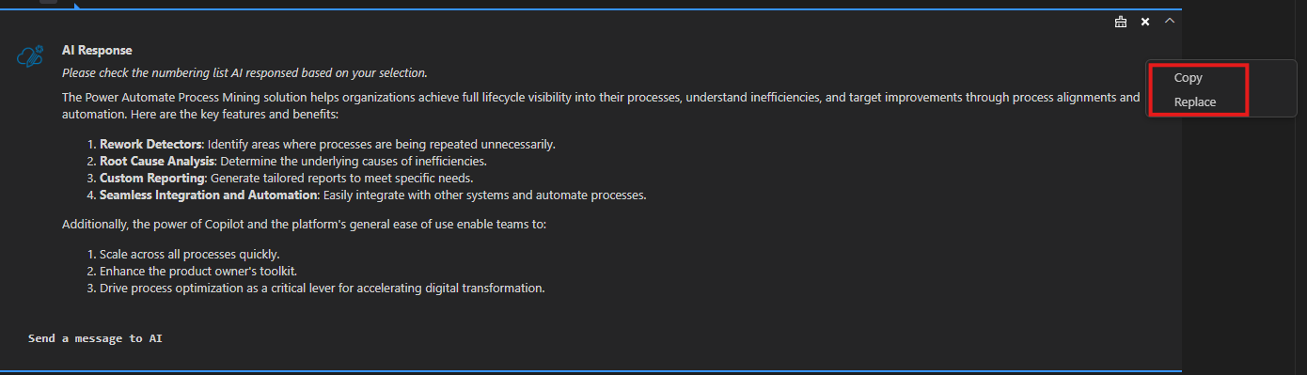

## Update Pub2Learn/Direct Publishing Module

You can also use AI-Powered Module Creation to update Pub2lean /Direct Publishing Module.

### Update Pub2Learn Module

1. Clone Pub2learn Module to local via VS Code

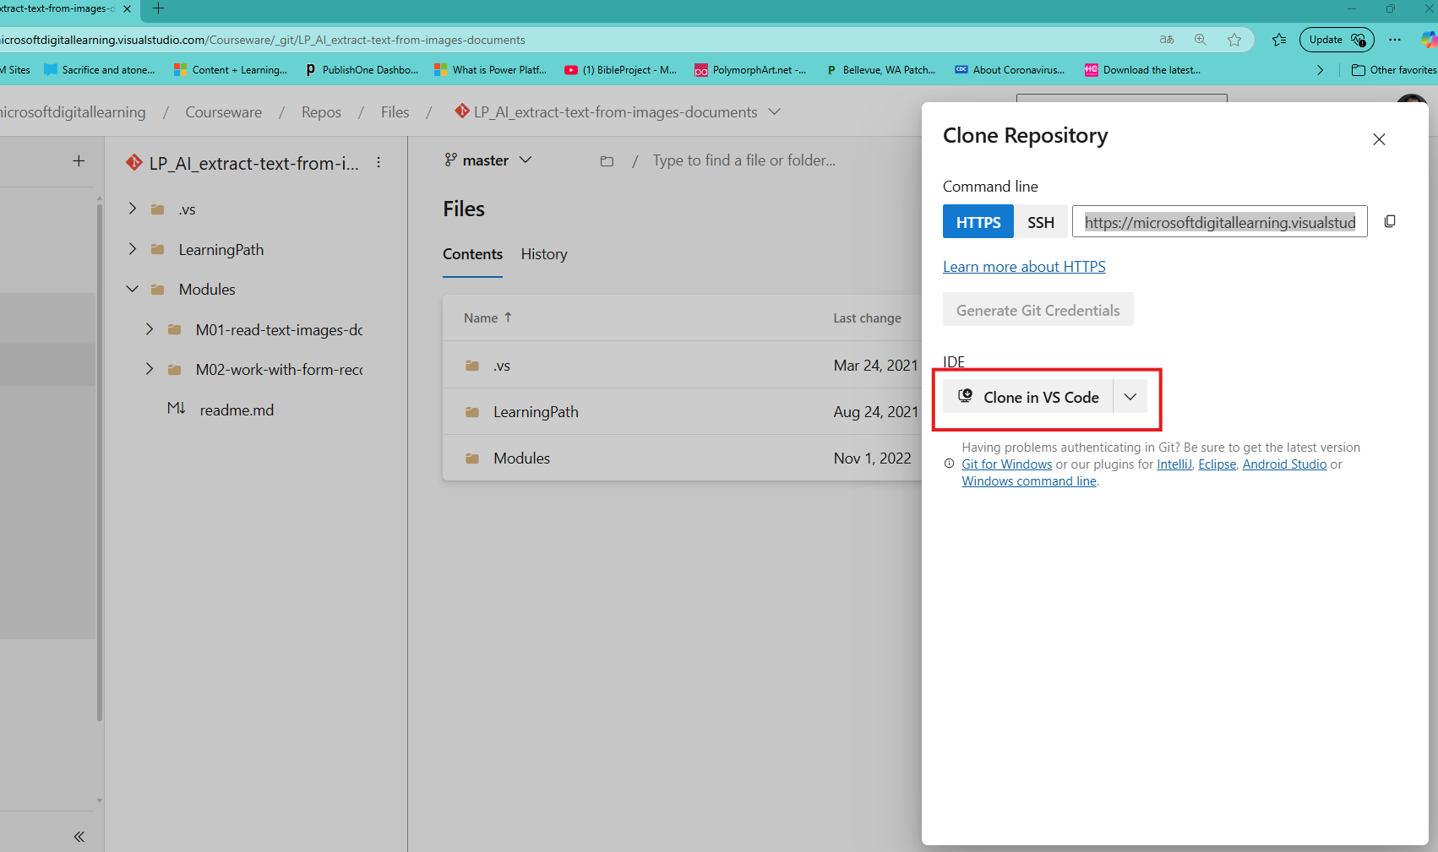

1. Click Open, to Open VS Code

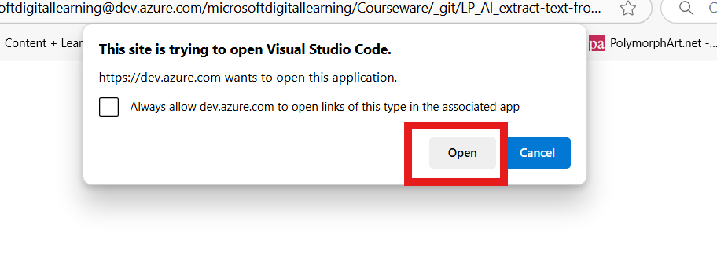

1. System will open VS Code and then pump out window, ask you to designate a local folder to store cloned repo. Choose existing folder or create new folder ,then click “Set as Repository Destination” button.

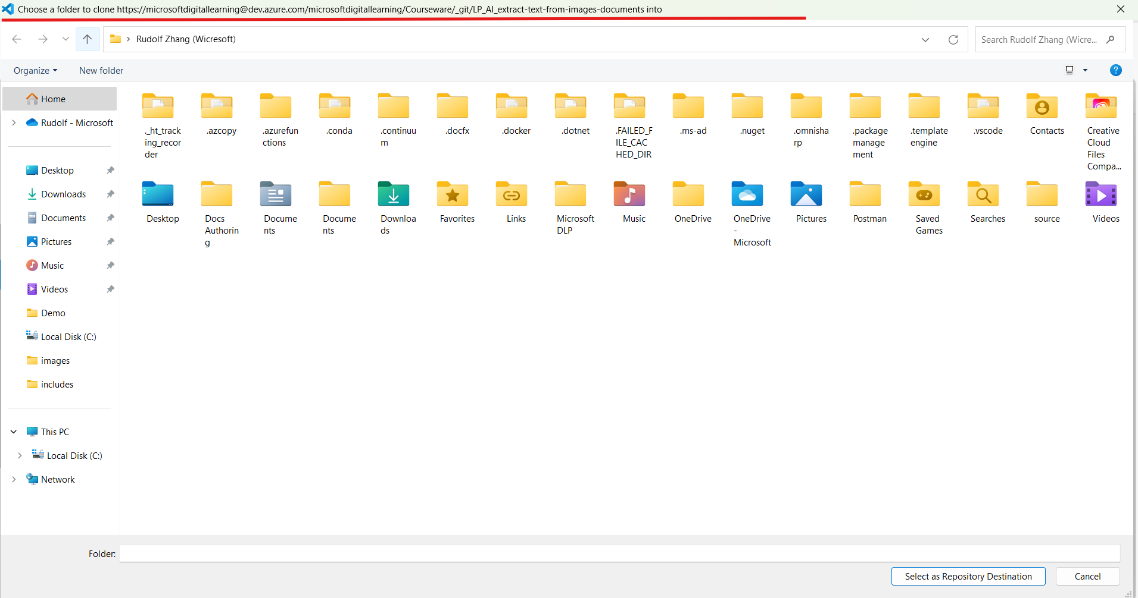

1. System will start clone the repo. When clone finished system will pump out a window. Click “Open in New Window”

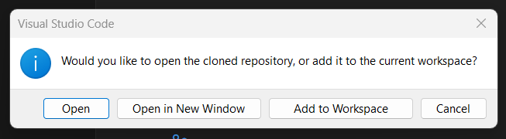

1. In VS code, Click **Source control**, Click **branch name** to switch to branch which contains content.

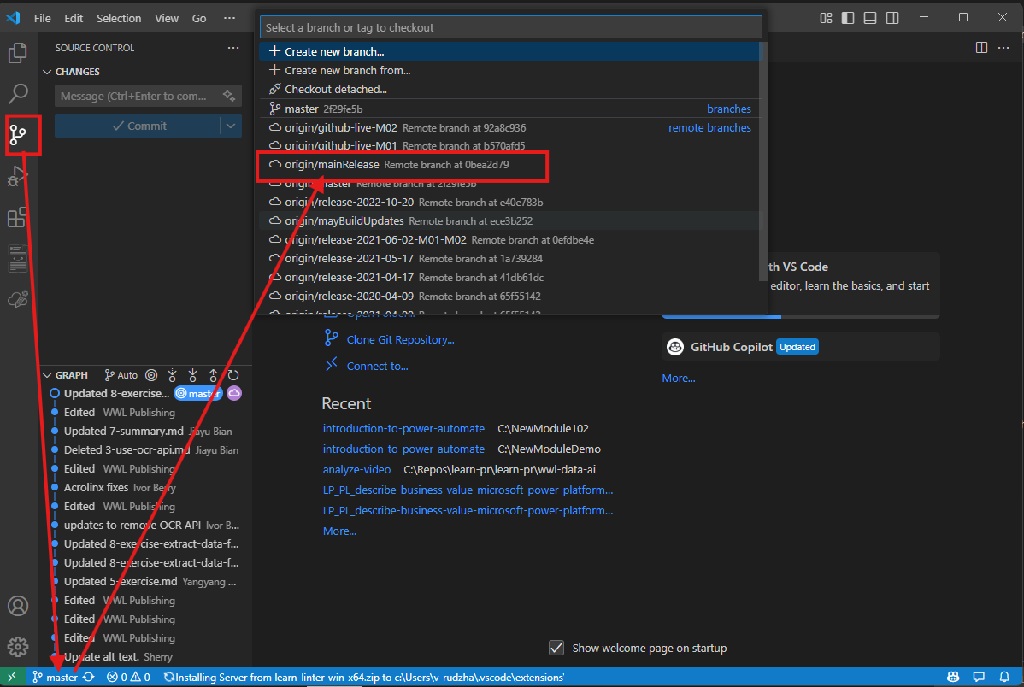

1. Click Explorer and then Right click the Module folder you want to revise. Select AI-Powered Module Creationà Open a module.

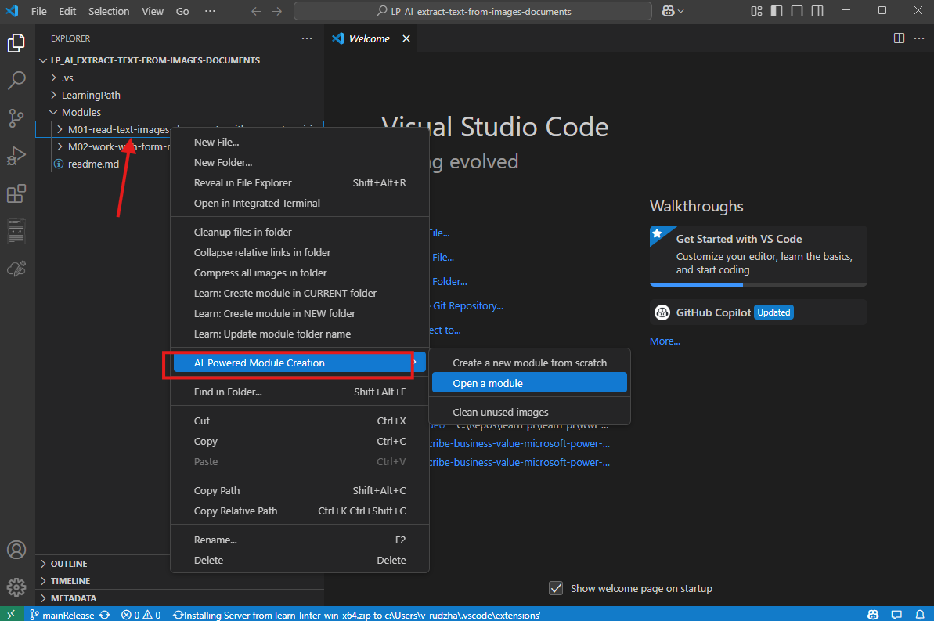

1. System will prompt that it is the extension will create profile for your module. Click **OK** to start this process.

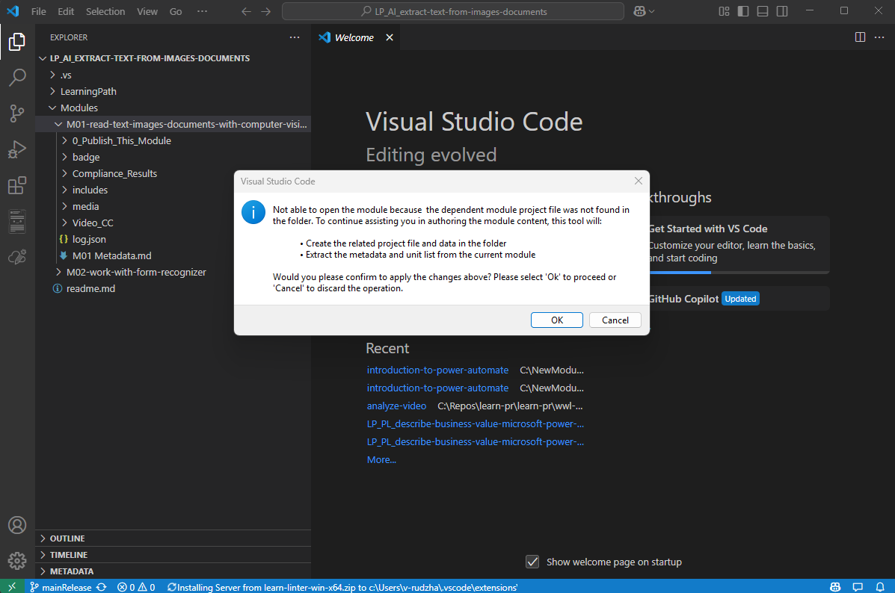

1. System will enter Module Design and then fill in product/Level and Role

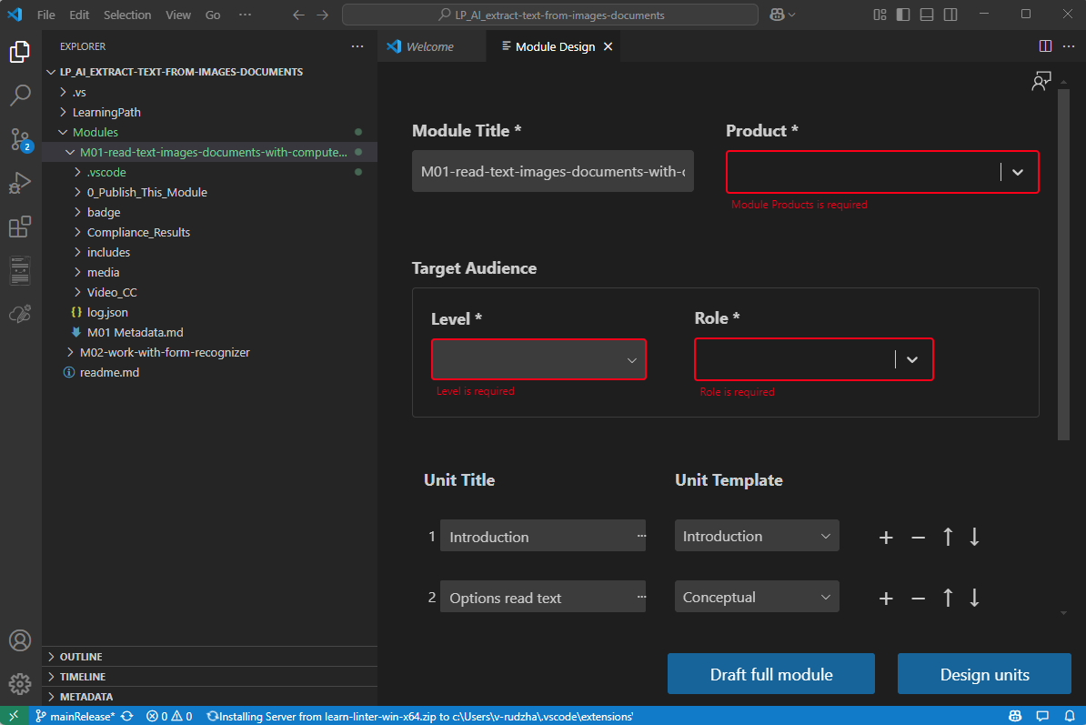

1. Click **Design Units**.You will see all units in generated status.If you want to regenerate a Unit. You could manually add datasource and Unit topics to draft a unit. Or if you want to revise a unit, just close Module designer and then open specific Unit. Then you can revise content with extension’s Content Refine Assistant.

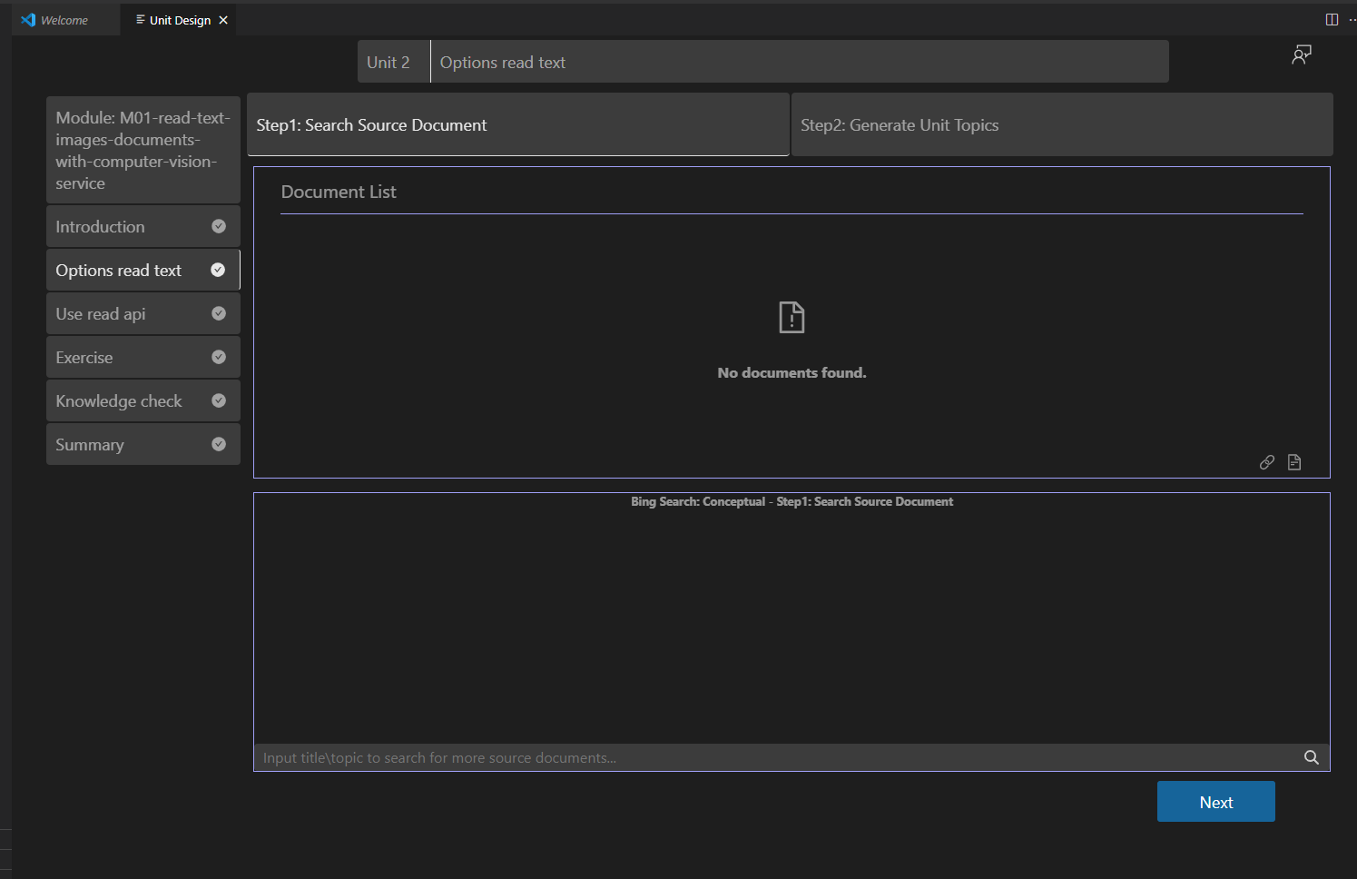

1. After all editing is done, push content update in VS code and then you can continue same pub2learn publishing process.

### Update Direct Publishing Module

1. Clone Learn Repo to local.Right click the Module you want to open.Select AI-Powered Module CreationàOpen a module

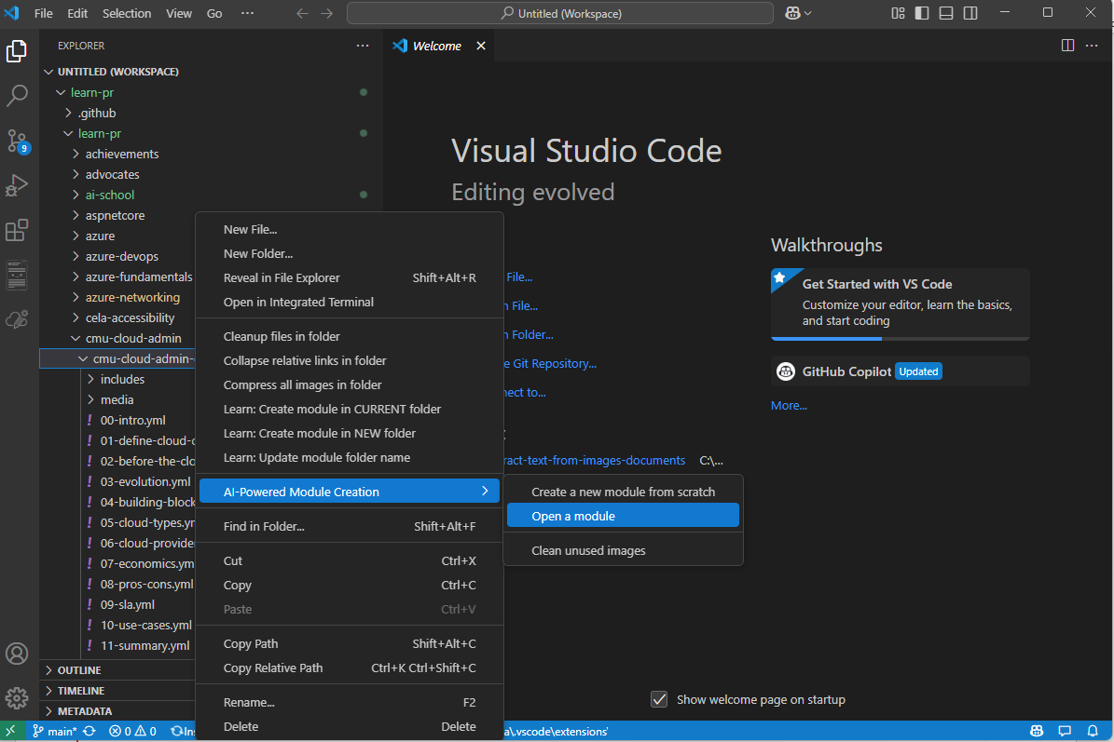

1. System will prompt that it is the extension will create profile for your module. Click **OK** to start this process.

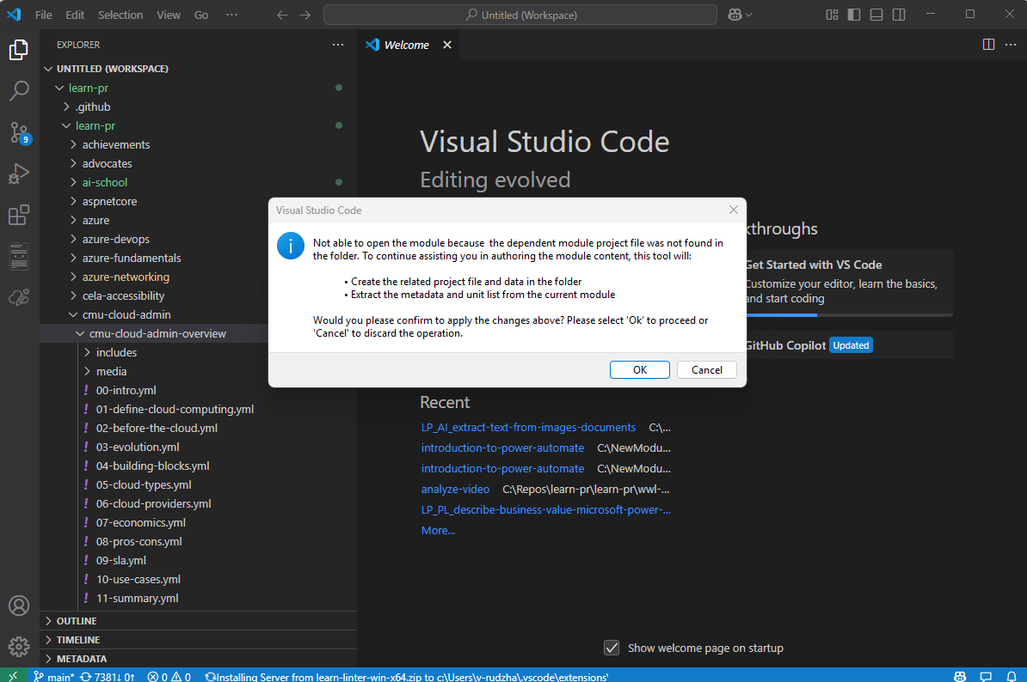

1. You will enter Module Designer.

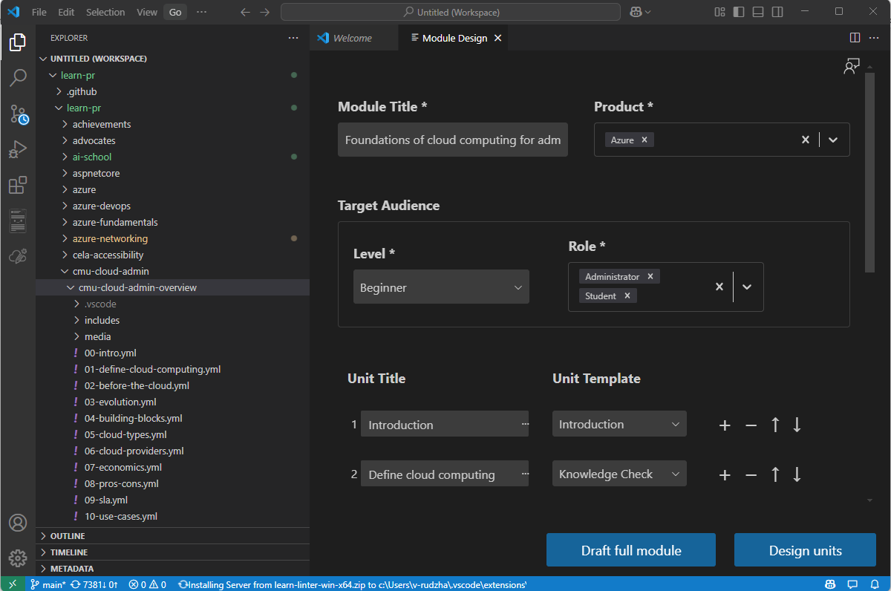

1. Click **Design Units**.You will see all units in generated status.If you want to regenerate a Unit. You could manually add datasource and Unit topics to draft a unit. Or if you want to revise a unit, just close Module designer and then open specific Unit. Then you can revise content with extension’s Content Refine Assistant.

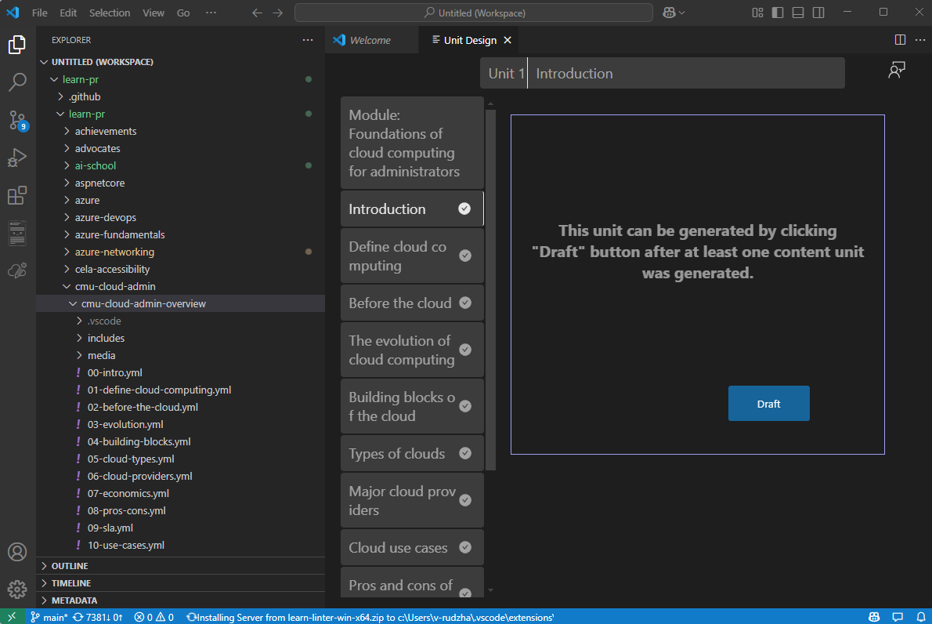

1. After all editing is done, you can continue with the Direct Publishing process.

## Best Practice

1. After finishing module scratching, if you are dissatisfied with design. Just don’t “Design Units”. Then the current design will be discarded. No markdown will be generated.
2. Due to unstable of AI model. If you met some unexpected situation. Just regenerating, it will eliminate most cases. Known unstable situation can be fixed by regeneration.

* Content embraced with []
* Introduction/Summary doesn’t cover all units

1. When use your own document as data source, please ensure the document is not set to high confidence level or the security setting will block service extract doc. This will work fine on “**General”** “**Public**” and “**Non-Business**” level. It would not work under “**Confidential**” and “**Highly Confidential**” level. For security reasons, this tool will not upload docx to any other storage or somewhere in cloud.
2. Sometimes when you open a module it will report link broken, but the file names are all good. Just turn off the extension and reopen the module, the issue will gone.  
   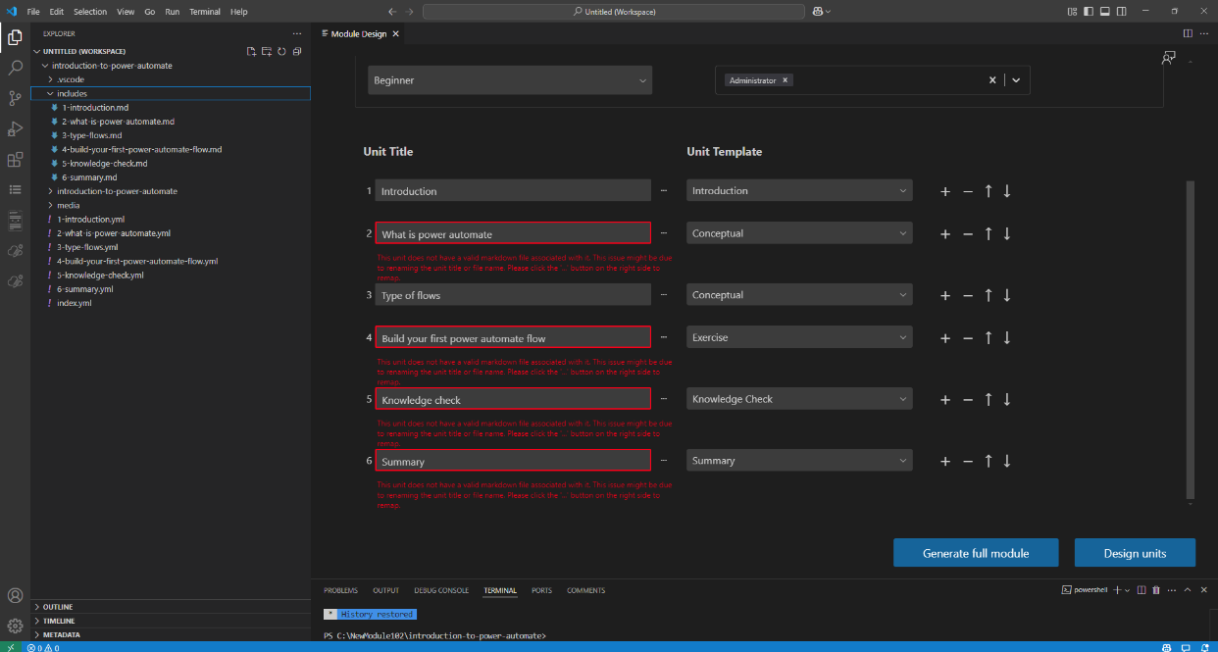

## Troubleshooting

Since extension continuously rolling out new versions. You may get some common issues during update. Here are the quick steps which can help tune on your side.

1. Restart VSCode  
   Sometimes, a simple restart can resolve many issues. Close all VSCode windows and restart.
2. Uninstall and Reinstall the Extension, then Restart  
   Open the Extensions view in VSCode, find your extension, click Uninstall. Restart VSCode, then reinstall the extension.
3. Manually Delete the Extension Folder  
   In certain cases, manually deleting the extension folder can help:
   * Path: C:\Users\<your-username>\.vscode\extensions\pdets-prod.new-module-creation-xxxx
   * After deleting the folder, restart VSCode and reinstall the extension.
4. Force Close VSCode and Restart  
   Run the following command in Command Prompt (CMD) to force close VSCode, then restart and reinstall the extension:  
   *taskkill /IM Code.exe /F*
5. Downgrade the Extension Version

If the latest version has issues, try downgrading to an earlier stable version. You can find older versions in the extension marketplace.

1. Disable Other Extensions

Sometimes, other extensions might conflict with this one. Try disabling other extensions, then repeat the above steps.

**Getting Further Help**

If the issue persists after following the steps above, you can get further help by sending email to [pdets@microsoft.com](mailto:pdets@microsoft.com) .